What’s the T? with Juno Dawson
Explore all things trans, queer and gender.
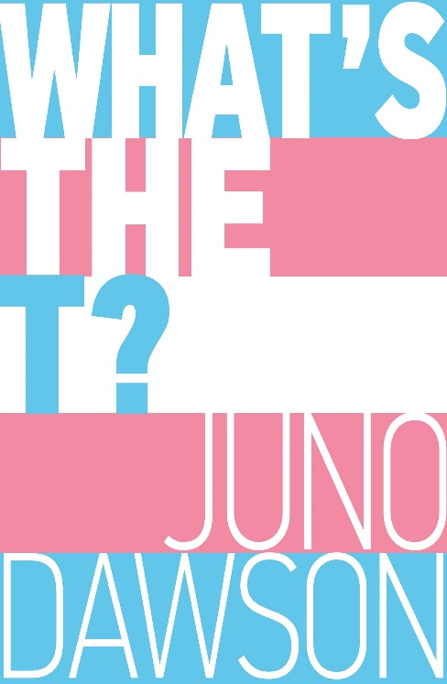
Image of book cover
Level:
Second Level / Third/Fourth Level – KS2/3
Explore themes of:
√ Gender, sex and sexuality √ Different Perspectives √ Family and Friendships √ Empathy
Subject Checklist:
√ English √ Social Studies √ Expressive Arts √ Health and Wellbeing

Read the Extract
Taken from p.10-15 of ‘What’s the T?’
Discussion Questions
- Have you heard of Juno Dawson before? What do you know about her? Have you read any of her books?
- Before you read the entire extract, just read the first paragraph of the book. Which one of these things do you think is true? Are you surprised when Juno reveals the answer? What do you think she means by this statement?
- How does Juno present her experience of childhood and growing up? How do you think she felt as a child and young adult?
- Juno mentions that when she grew up the internet wasn’t widely available. Where do you think young people at that time would get information on sex and sexuality. What are the issues (or dangers) with those sources of information? What are the issues (or dangers) of teenagers getting information from the internet? What are the positives of both?
- What made Juno decide to transition?
If you’re unsure of any terms we use in this resource then please refer to the glossary on p286 of What’s the T?
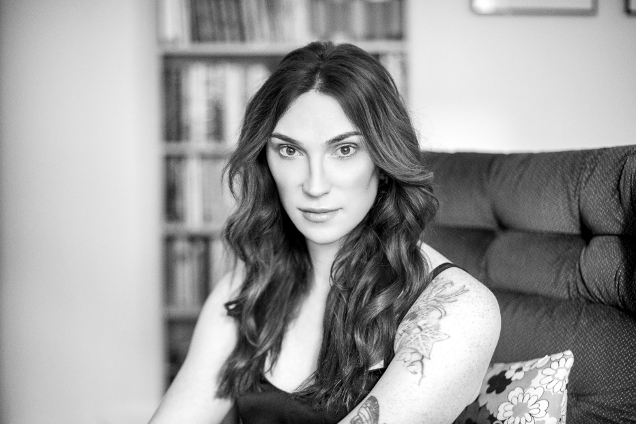

Get to Know the Author and the Book!
Juno Dawson is a British transgender activist, and writer of young adult fiction and non-fiction, including This Book Is Gay, Mind Your Head, Margot & Me, The Gender Games, Clean and Meat Market.

Activity 1: Like a Girl
On p.18-19 Juno talks about gender.
“We all have a relationship with the notion of gender because we were ALL labelled at birth. Even if you are intersex, the doctor told your parents you were male or female and from that moment on, a massive cartoon anvil of gender expectations landed on your head.”
- Make two headings on a piece of paper:
This is what boys do. and This is what girls do.
- Starting with the examples Juno gives us, “rough and tumble” and “pink and sparkly” write a list under each heading of what our society thinks boys and girls should do, be or like.
- Think about your interests, hobbies and likes. Are they traditionally categorised as masculine or feminine?
- What does it mean to behave like a boy or behave like a girl?
- What does our society think of people who don’t adhere to these stereotypes? Why do you think that is?
- Watch the following advert which Always screened during the Superbowl in 2015. (Hit Ctrl + Click to activate link.)

https://www.youtube.com/watch?v=F_Ep0O5fWN4
  - What point is the advert trying to get across? Do you think it does it well?
  - What effect do you think the negative connotations of doing something
“like a girl” can have on young women?
  - Can you think of any converse examples where similar stereotypes or use of language may have negative effects on men? (For example what about “man up”?)
Activity 2: The Gender Games
On p.27 Juno quotes the World Health Organisation’s definition of gender:
“…the characteristics of women, men, girls and boys that are socially constructed. This includes norms, behaviours and roles associated with being a woman, man, girl or boy…”
- In different countries and at different times in the past different attributes have been attributed to different genders. For example in different places and at different times in the past men have worn dresses.
  - Can you think of or research some other examples of this?
  - What does this make you think about gender?
- What does it mean when Juno describes gender as a “social construct”?
- What do you understand as the difference between gender and sex (if you’re struggling see p.29.)
- What do you understand as gender expression. Talk about the difference between biological sex, gender and gender expression.
- On p.36 Juno lists some things which are very gendered in our world. What would you add to this list?
Body Hair Names Toys Hobbies Hair Clothes
Activity 3: Smash the Patriarchy
On p.31 of ‘What’s the T? Juno defines the patriarchy:
“A patriarchy is a culture in which men hold the majority of power, therefore creating a world which best suits men. Our world – pretty much the whole world – is a patriarchy. If you look at the people in power, they are mostly men.”
Give THREE examples of what you understand as the patriarchy.
The opposite of a patriarchy is a matriarchy. What is the definition of a matriarchy? Can you think of any examples?
Discuss how or why you think almost the whole world became a patriarchy.
What masculine values do you think we commonly associate with leadership?
Can you name any female leaders? Which values or attributes do you think they hold? Are these attributes traditionally masculine or feminine? Do you think they are positive attributes to hold in leadership? Discuss what both traditionally masculine and feminine attributes could bring to a position of power.
Activity 4: Implicit or Structural Transphobia
On p.153 Juno lists some examples of Implicit or Structural Transphobias:
“The world assumes everyone is cisgender. It has been set up to work best for cis people. And so…Sanitary products are marketed towards women. Assumptions are made about ‘women’s bodies’ and ‘men’s bodies’. Maternity services are geared towards ‘women’ and ‘mothers’.”
What other examples of implicit or structural transphobia can you think of. Would they affect men, women or both?
How do you think they would affect trans people?

Your Turn: Rewriting History!
Activity 1: The Transgender Hall of Fame!
Throughout What’s the T? Juno incorporates pages from the “Transgender Hall of Fame” telling the story of people who have paved the way for transgender people.
- Think of or research the story of a transgender person who you respect and think paved the way for others (Or if you’re stuck you could research one of the “early pioneers” which Juno mentions on page 57 onwards) then write your own entry in the Transgender Hall of Fame. You could even illustrate it in the style of Soofiya, Juno’s gorgeous illustrator!
Activity 2: The Family You Find
“Family doesn’t always look like a child’s drawing of one:
a mummy and daddy stood next to a square house with red windows.”
On p.236 Juno talks about “found families”, which describes how your “family” does not always need to be people you are related to but can also be made up of close friends. She explains that the concept is popular amongst trans and/or non-binary people both because family relationships can sometimes be hard, and also because having relationships with other queer people can reduce the need to explain every aspect of your experience at all times.
- Think about who you consider to be your family. This could include your biological family, close relatives, friends, other role models.
- Think about your relationships. Are you close because of shared experiences and similarities or for other reasons?
- Draw a picture of your “family” and, if you’re comfortable, explain why you have chosen these people.

Reflection and Further Questions
Think over all that you have learned today. How have today’s exercises made you think about the ways in which we as a society understand and navigate gender? How will this influence you going forward? Are there any changes you will make in the future to the way you use gendered language?
Lastly, do you have any final questions you would like to ask Gina if you got the chance? Try to think of at least two and make a note of them.
Keep your eye out for more awesome books from Gina Martin, as well as the other authors from the Edinburgh International Book Festival!
If you, or someone you know, are affected by the issues in this resource, or just want to find out more, these links are some good places to start. (Hit Ctrl +Click to follow the links.)
All About Trans
Press for Change
Gendered Intelligence
Stonewall
Mermaids
The Albert Kennedy Trust
This Book is Gay by Juno Dawson
The Gender Games by Juno Dawson
Trans Power – Juno Roche
Childline
Switchboard LGBT

