Reading Scotland: Ross Sayers with Niamh McKeown, Adventures on the Clockwork Orange
Explore setting, relationships and voice in this dynamite novel about time-travelling in Glasgow!
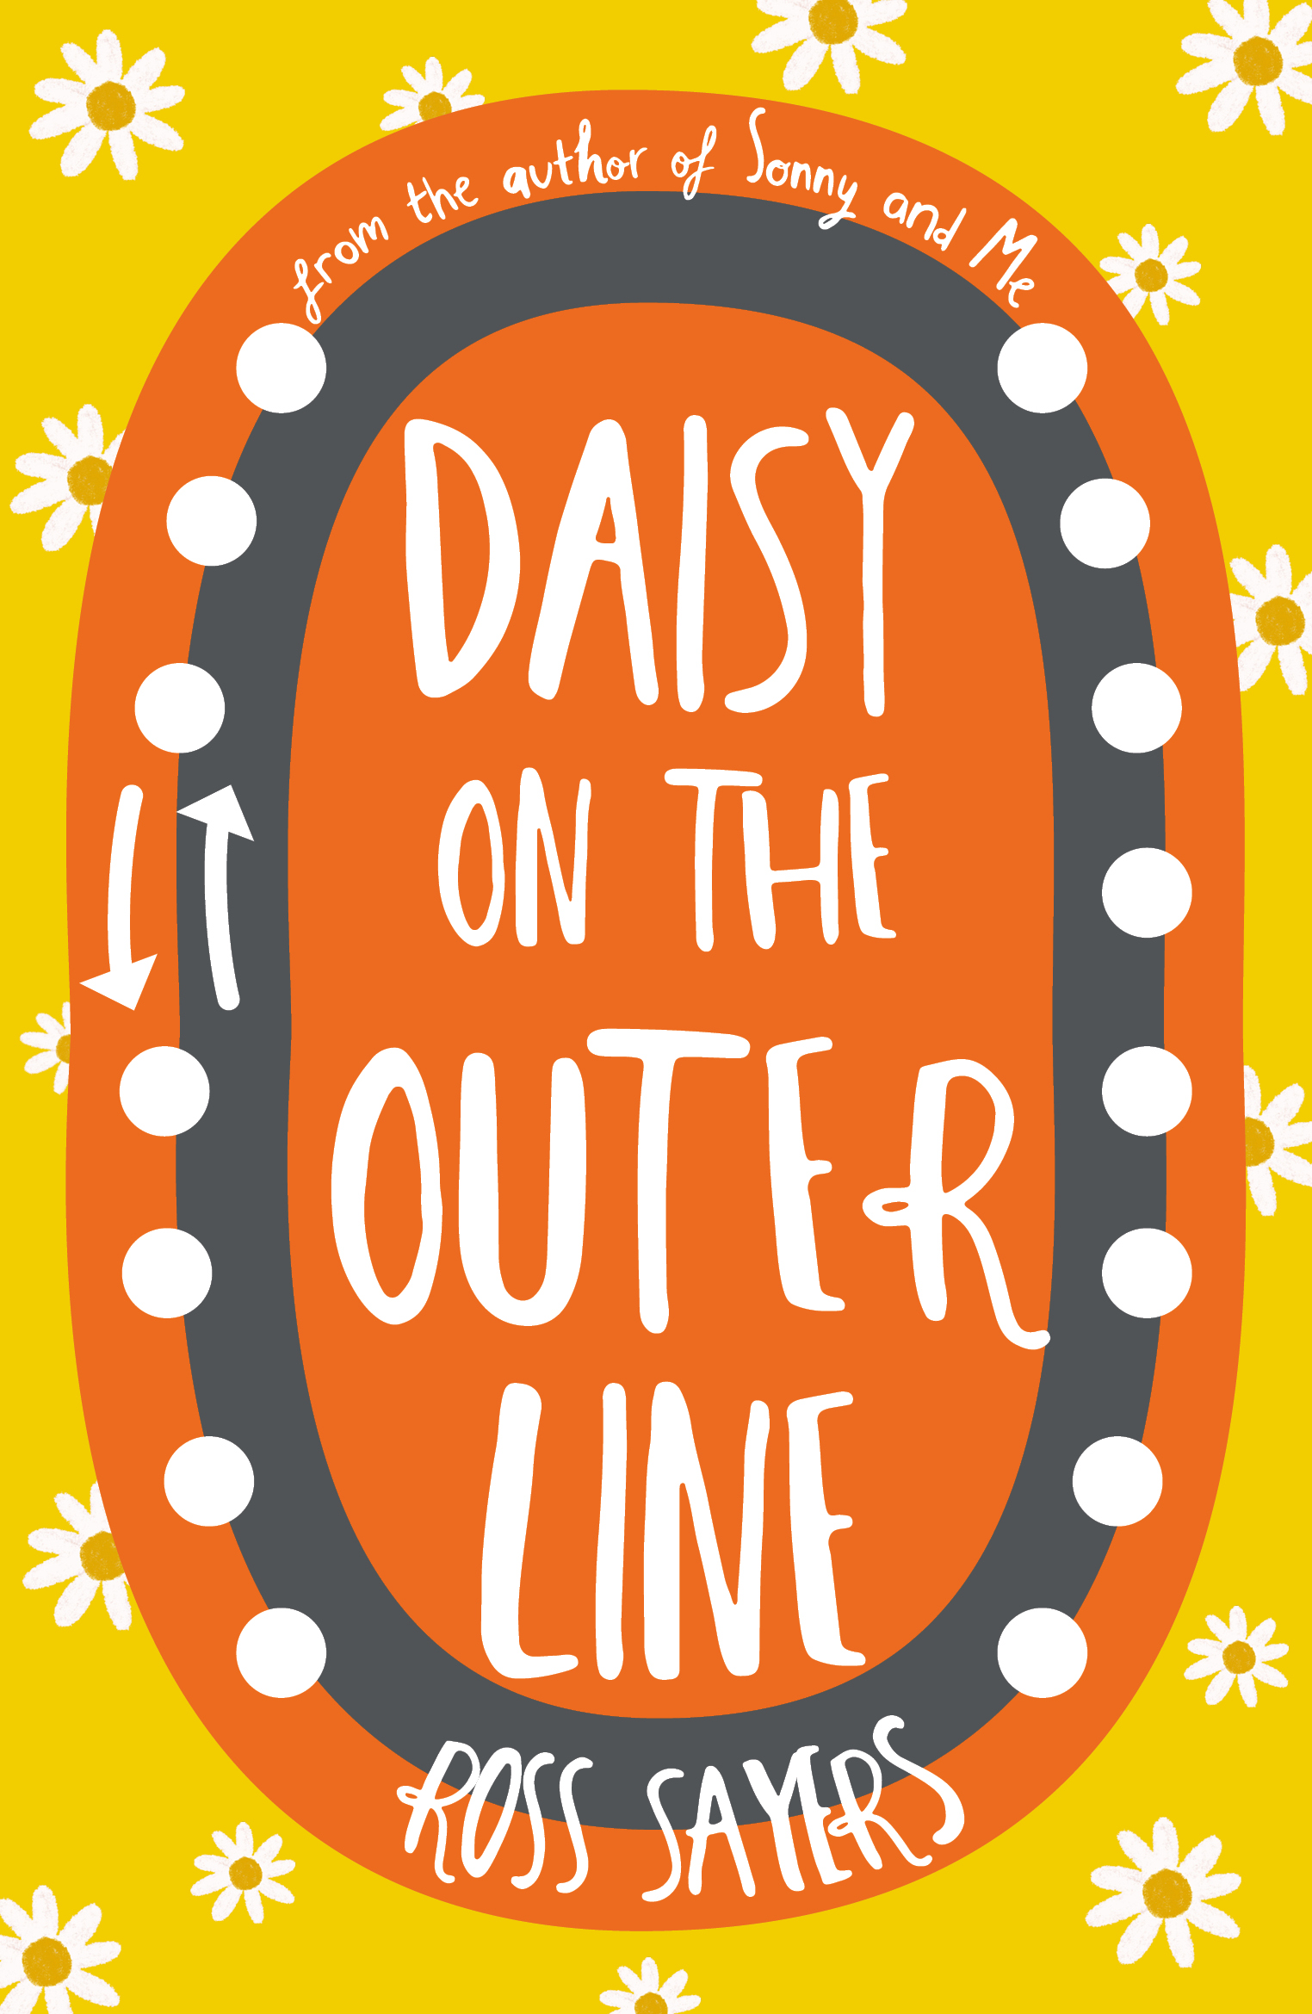

Image of book cover(s
Level:
Senior Phase
Explore themes of:
√ Time Travel √ Friendship √ Mental Health √ Place
Subject Checklist:
√ English Language √ Social Studies √ Expressive Arts
*NB: Contains graphic language and strong themes of mental health and substance abuse.

At a Glance:
Before watching the event or reading the extracts!
- Do the title and cover give you any clues what the book may be about or where it might be set?
- Whose ‘voices’ or ‘perspectives’ do you think you will hear in this book?
- What are some themes you think the book might address?
Read the extract:
Read chapter one, pages 1-6 of ‘Daisy On The Outer Line’
Discussion Questions:
- Why do you think Ross has chosen to write his book in Scots? What affect does this have upon the narrative?
- What is your first impression of Daisy? Do you like her – if so – why?
- What can you tell about Daisy and Siobhan’s relationship from this extract?
- Do you think Daisy is happy?
- Why do you think Siobhan has asked Daisy to keep a diary on her phone?
- Why do you think it is important to have conversations surrounding mental health?
- Identify two writing techniques that Ross has used in this first chapter to help embellish our understanding of Daisy’s character.
- Do you find Daisy a relatable character? If so, why?
Watch the event:
Watch our Reading Scotland: Ross Sayers with Niamh McKeown, Adventures on the Clockwork Orange event online. It can be found via the edbookfest.co.uk website.
Discussion Questions:
- Do you agree with Ross’ statement that young people like to read books about people older than they are?
- Why do you think it is important for audiences to see characters change over the course of a book?
- How easy or otherwise do you think it is to write in the persona of a person of a gender identity different from yours? How would you go about trying to understand their mindset?
Literary examples of Scotland and youth are often from the male perspective. Niamh writes that she portrays “wild, angry women who challenge traditional ideas of womanhood.” What do you take from this sentence?
Exercise 1: Place as a character:
Think about what Ross, Niamh and Lewis were talking about when they said that Glasgow featured as a character in the book. Do you think this is true?
- In pairs, talk about how a place can act as a character in a book. Are there any other examples of this you can think of? (Hint – it doesn’t have to be limited to books – in fact, for those of you who have seen them – maybe think about a few of film/TV references Ross puts in the book…)
- How would you describe your hometown to someone who has never visited?
- Do you think certain cities have distinct characteristics?
NEW YORK PARIS EDINBURGH
Working in pairs, try to come up with at least three adjectives for each city. As a bonus round, try and think of some books, films, or TV shows that use characteristics of the city as a narrative vehicle.
- Write a short paragraph describing a city or place of your choice as if they were a person. For example, ‘London was dismissive – she looked right through you when you spoke.’
Exercise 2: Big Mood
Niamh mentions that as part of her preparation for making the film she created a mood board.
- Do you know what a mood board is? What is its purpose?
- Take a look at Niamh’s Pinterest board here: https://www.pinterest.co.uk/niamhmckeown/flooers/

Discuss in a group:
- Which aspects of the mood board can you see carried through to the film?
- Do you feel Niamh’s mood board accurately captures the mood of the film?
- Are there any aspects of the mood board which you don’t think carry through to the film?
- Are there any aspects of the film which you don’t think are represented in the Pinterest mood board?

Niamh chose to look closely at Daisy’s character because that was what interested her most as a reader. Can you think of another example where the character in a book has stood out to you particularly? Try to imagine them through the lens of a filmmaker – which aspects of their personality would you choose to portray and how would you translate this onto camera?

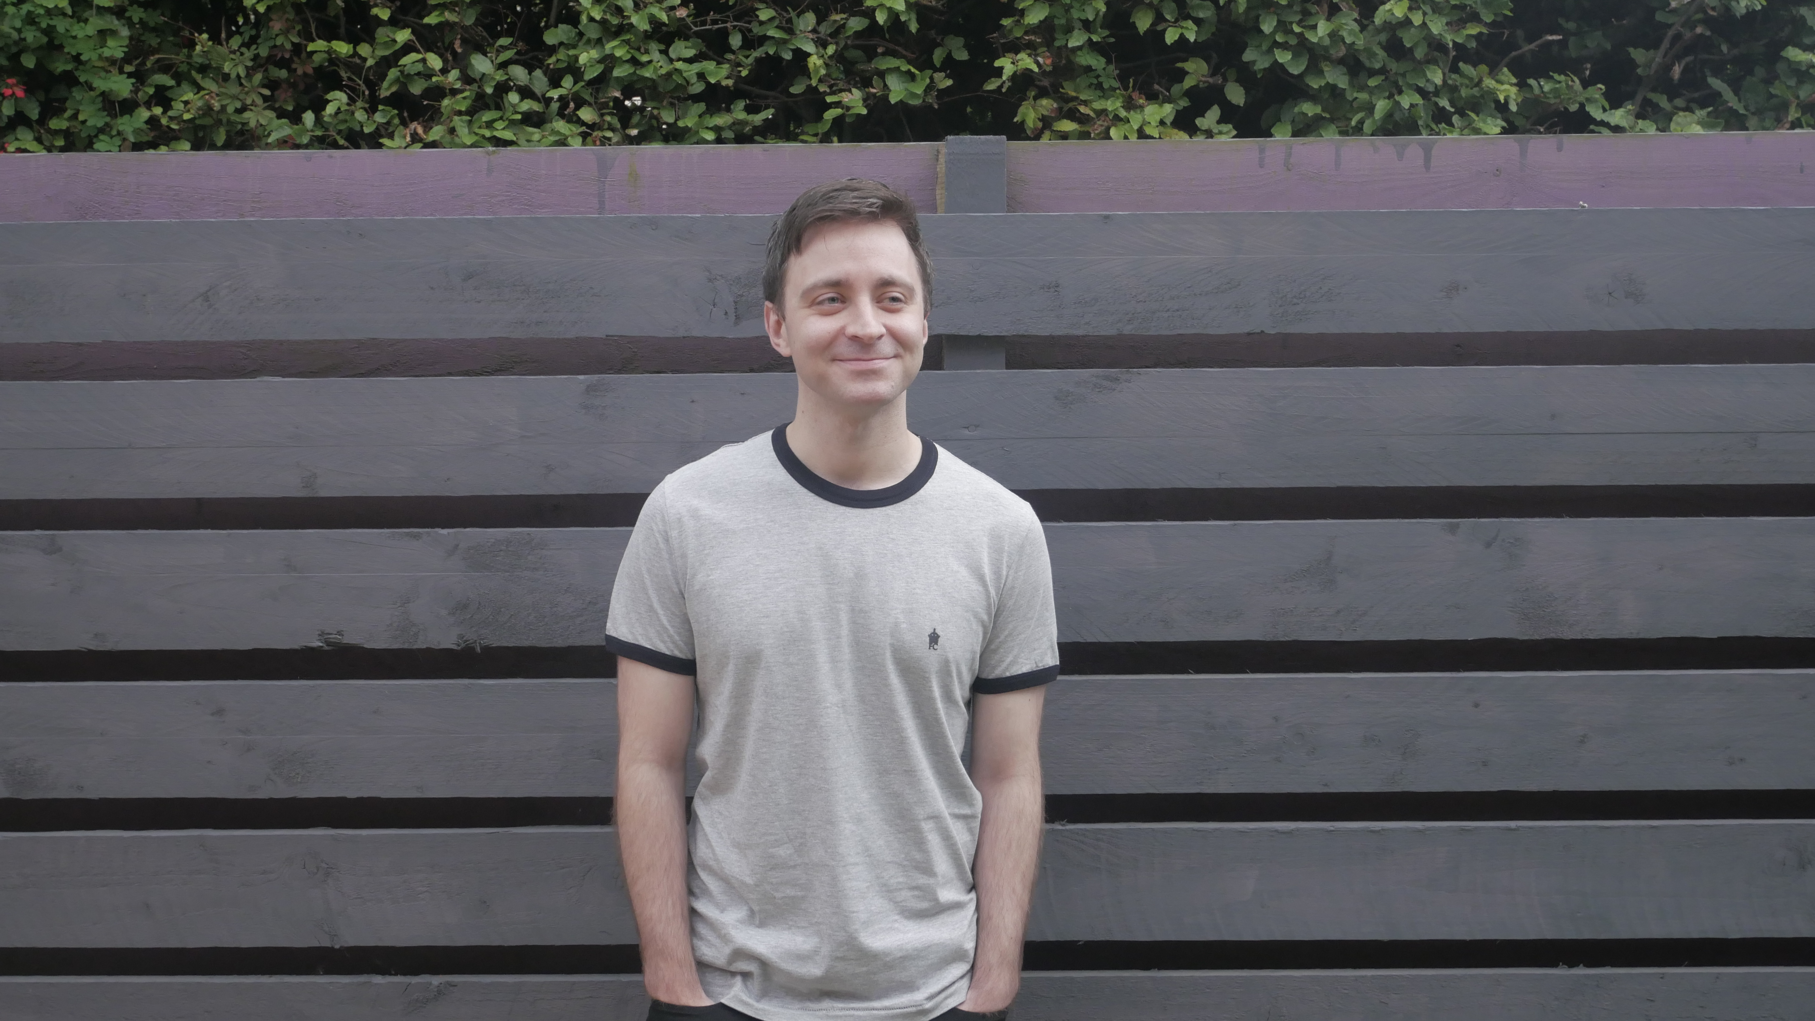
Get to Know the Authors and the Books!
- Ross is originally from Stirling but now bases himself in Edinburgh. He was inspired to write Daisy On The Outer Line one evening at 11:37pm on April 21st 2018 precisely, as he stood on the Cowcaddens subway station in Glasgow where the novel is set.
Activity 1: Growing up in Scotland
Ross talks about wanting to explore what its like growing up in Scotland as a young person in today’s world. In pairs, discuss how you feel growing up in your city has affected you.
- How much do you think culture and setting influence a person?
- Can you identify any traits or habits that you feel are distinctly representative of your city – this could be language, slang for example or insider knowledge about the geography of your town.
Write a short paragraph about how the city you currently live in has influenced you and shaped your world view.
Activity 2: Back tae the future!
Daisy goes on a journey through time – think about how you might react if you time-travelled.
- Write a short story about what you might do if you found yourself catapulted back 16 days into the past.
- Think about; what sort of things you would change? What would you do the same? Is there anything you would be sad to miss?
- If you finish early, think about if you could visit any part of history – where would you go and why?

Reflection and Further Questions:
Reflection Activity:
Think over all that you have learned today. What have you discovered about relationships, language and setting?
- What do you think about Ross’ portrayal of how anxiety manifests itself in Daisy’s character? Do you think this is an accurate portrayal?
- Why do you think it is important that books for Young Adults explore topics of mental health?
Lastly, do you have any final questions you would like to ask Ross or Niamh if you met them in person?

