Adventuremice! with Sarah McIntyre & Philip Reeve
Meet the Adventuremice and set out on your own creative adventure!

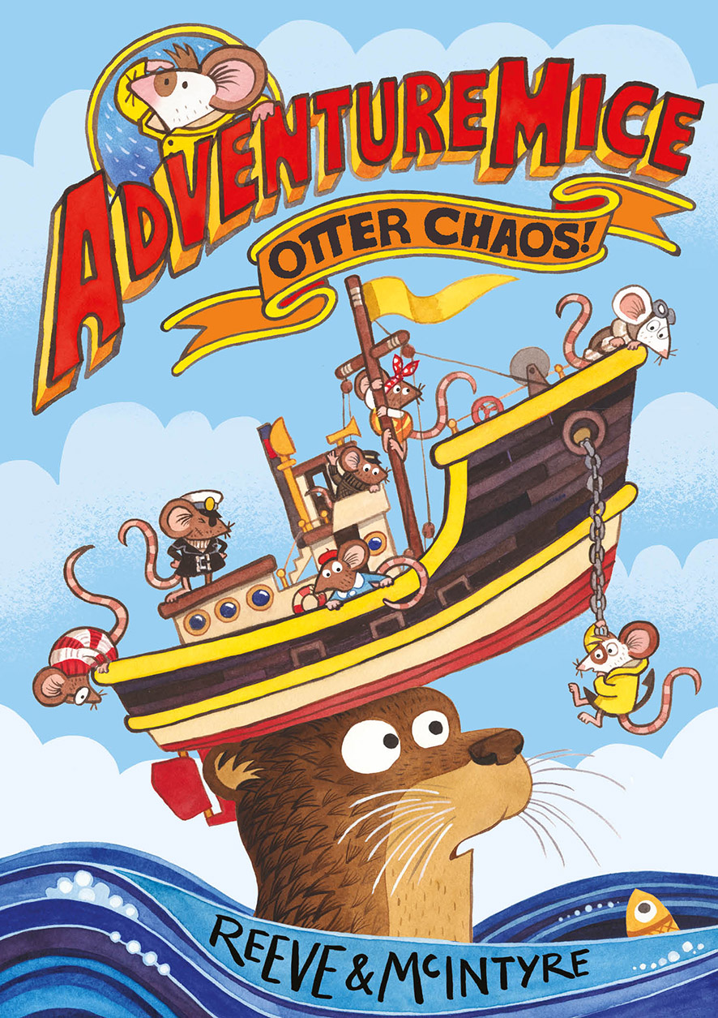
Level:
Early Level / First Level – KS1/2
Explore themes of:
√ Language √ Character and Place Creation
Subject Checklist:
√ Expressive Arts √ English Language √ Creative Writing

At a Glance
Before watching the event or reading the extracts! Look at the book cover.
- Who do you think the Adventuremice are. What do they do?
- What do you think is happening in the cover image?
- How do each of the characters on the cover feel and what are they thinking?
Read the Extracts
Taken from Chapter One of “Adventuremice: Otter Chaos”
Discussion Questions
- What words does Pedro’s dad use to describe adventures?
- What describing words (adjectives) are used to describe Pedro’s family’s life at Hilltop House?
- What does Pedro want to do?
- Look at what Pedro packs in his suitcase. Do you think they are useful things to take when you’re ging on an adventure? Why or why not?
- What happens when Pedro gets to the beach?
- Who or what saves Pedro?
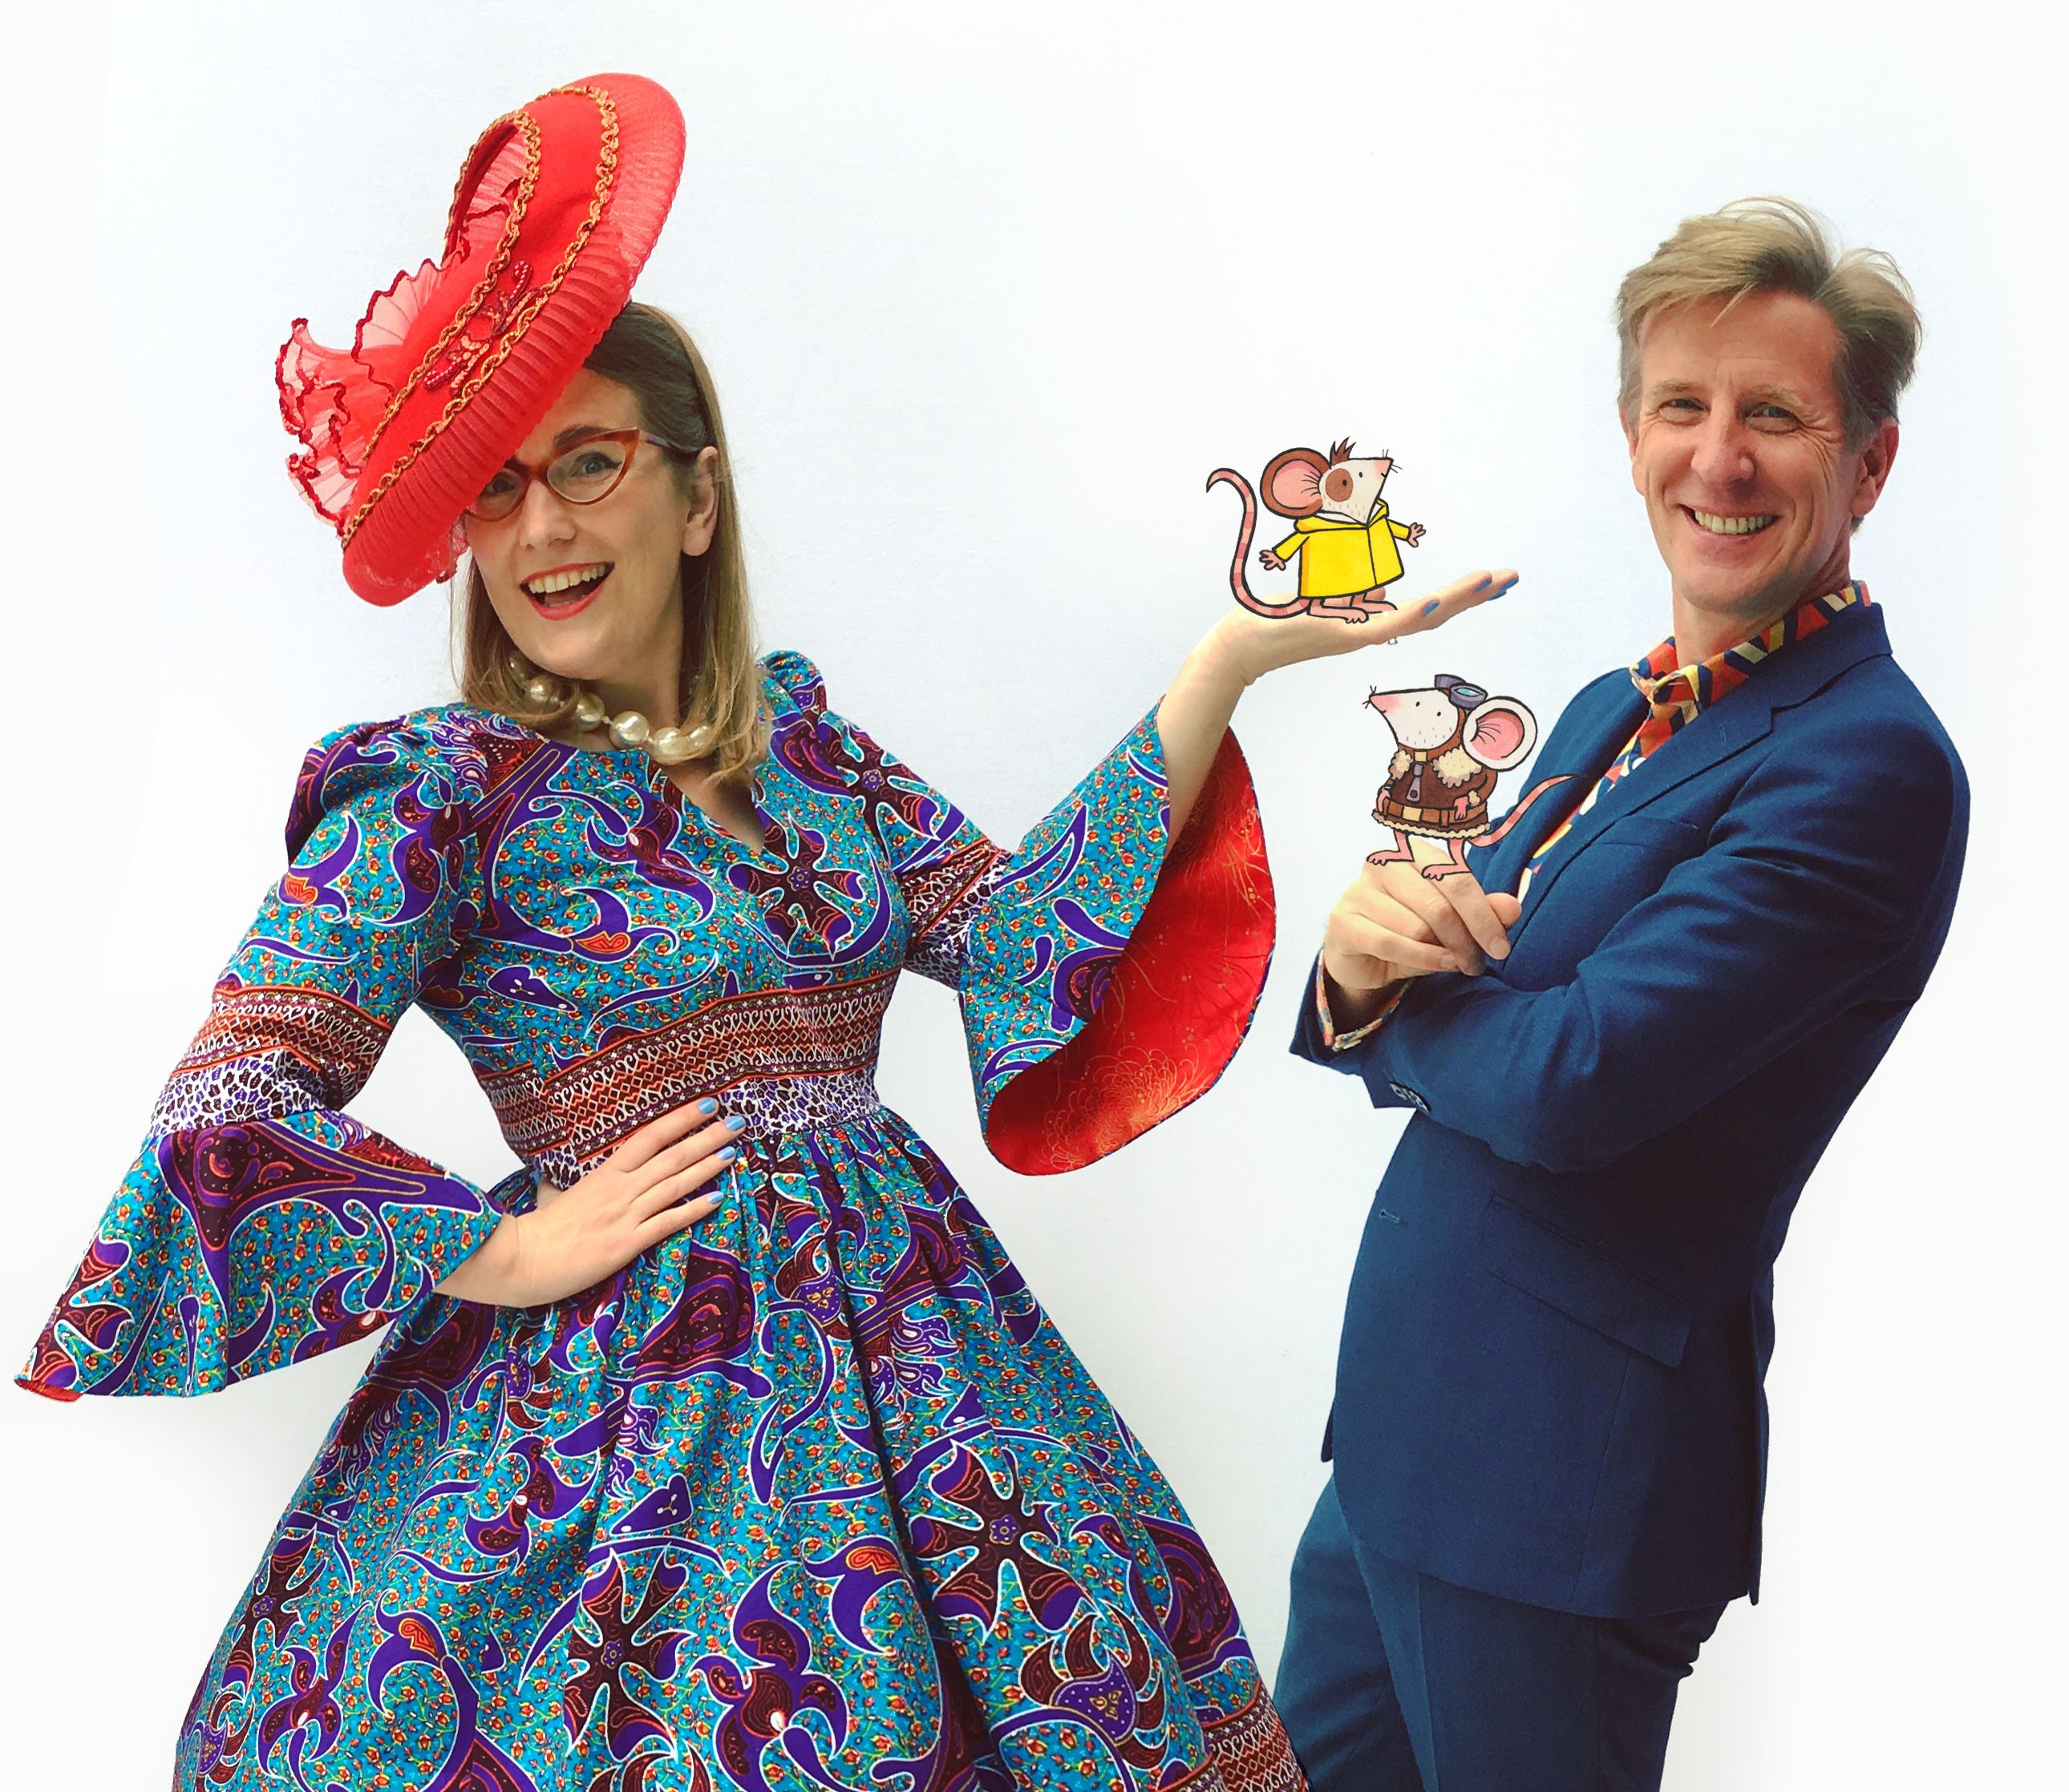
Activity 1: Meet the Adventuremice
Match up the adventuremouse with their description from the book by drawing a line between their name and the description.

Pedro “The bravest of all, and the founder of the Adventuremice.”
Ivy “explores the deep in her submarine.”
Bosun “She’s brilliant at making gadgets and machines that keep everything running.”
Juniper “I came looking for adventures, but I don’t think I like them after all.”
Millie “The bravest ship’s mouse that ever sailed the seven seas.”
Skipper “Our first aider and rescue helicopter pilot.”

- Fledermaus, who Pedro meets first, isn’t formally introduced in the book. Write a short, one sentence description of him.

Activity 2: Come up with your own Adventuremouse character!
Each of the Adventuremice play an important part within the team.
- Plan ideas for your character using the questions below.
- Then, draw them on an A4 sheet of paper including lots of colour! Write a speech bubble next to them so that your character can introduce themselves.
- Share your new characters together and talk about the adventures they might have!
Plan for my Adventuremouse character:
  - What is your character’s name?
  - What do they look like?
  - What do they wear and what materials do they use?
  - Do they have a vehicle that they travel in?
  - What skills do they have that would be useful in adventuring?
  - What do they do within the Adventuremice team?
Draw your character on a blank sheet of paper. Add a speech bubble next to them so they can introduce themselves!
Share your characters together and talk about what adventures they might have!
Activity 3: Make your own Mousehaven
Adventuremice includes lots of amazing descriptions and awesome pictures of the places where the mice live including Big Island, Mousehaven and Mousebase. Check out the map of the Mouse Islands at the back of the book!
- Come up with a plan for your own Mouse Island or Mousebase.
- Who lives on it (if anyone)? Is it a safe place, or are there dangers.
- The Mice sometimes make use of human objects such as Box Island, the toy plane or fireworks. Do any human items appear in your place?
- Draw a picture of your place and add arrows pointing out all the interesting, cool or dangerous things!
- If you want you could even try creating a model of your place using household items and craft materials!

Activity 4: A postcard from the Mouse Islands.
In the last chapter Pedro sends a postcard home to his family, telling them about all of the amazing things he’s been doing with the Adventuremice.

  - Imagine that you too have gone on an adventure with the Adventuremice to the Mouse Islands.
  - Write your own postcard home describing all of the exciting things you’ve been doing.
  - Once you’ve written your postcard try to rewrite your text as small as you can (but so it’s still readable!) Make your letter into a tiny, mouse-sized postcard.
  - Don’t forget to draw a picture on the front, and include a tiny stamp and address!
Activity 5: A Terrible Beastie
Pedro has never seen an otter before so when, on p36, Bosun describes them as
“as big and fierce as a cat, as clever as a dog and as hungry as a shark.”
Pedro imagines a terrible creature, which doesn’t look like an otter at all!!

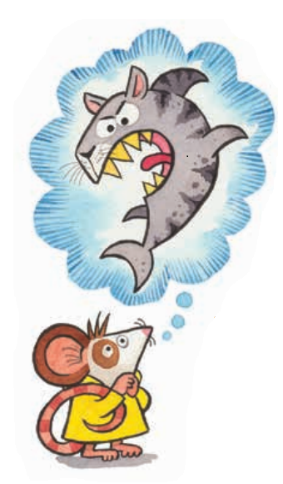
  - Get into pairs and each choose an animal but don’t tell your partner what it is.
  - Take turns to describe your animal to your partner slowly.
  - Your partner should draw what you’re describing.
  - When you’re finished reveal your picture to your partner and tell each other what the animals were.
  - Do your drawings look like the animals – or are they really different!?

Reflection and Further Questions
Reflection Activity
Think over all that you have done today. Did you enjoy creating your own characters and places? Have you come up with any ideas of things which could happen there? Maybe you’re inspired to write a story!
Lastly, do you have any questions you would like to ask Sarah and Philip if you got the chance? Try to think of at least two and make a note of them.
Keep your eye out for more awesome books from Sarah McIntyre and Philip Reeve, as well as the other authors from the Edinburgh International Book Festival!

