Learning to Love Yourself with Amara Sage and William Hussey
Explore two YA novels with big hearts and big themes!
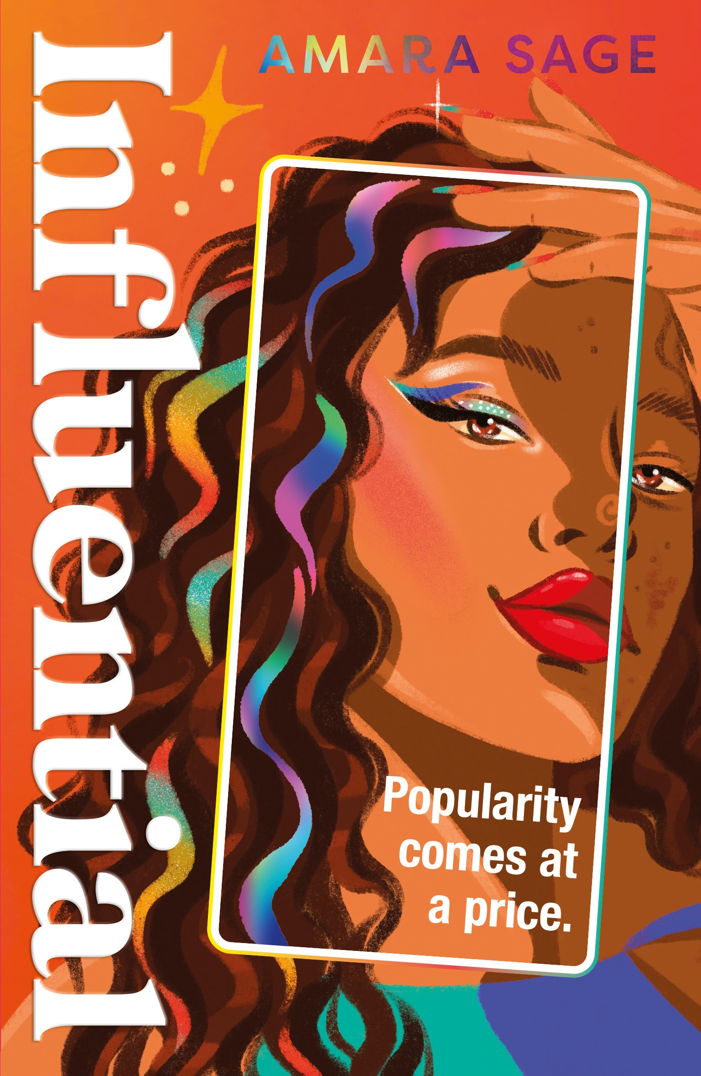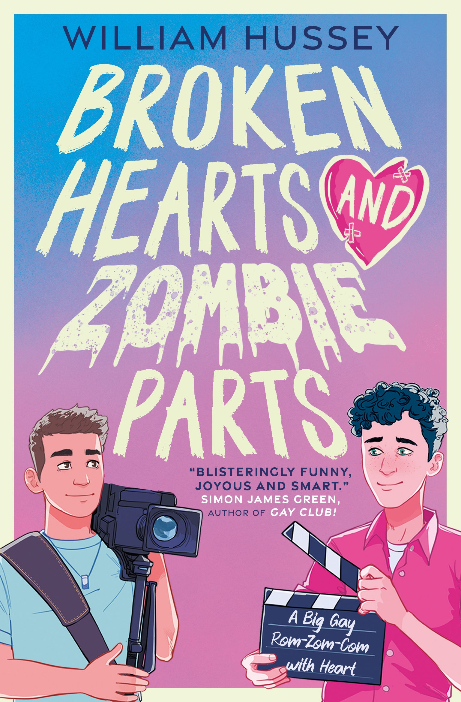
Level:
S3-S5/ Third and Fourth and Senior Phase
Explore themes of:
√ Social Media √ Mental Health √ Body Image √ Friendships and Relationships
Subject Checklist:
√ Health and Wellbeing √ Expressive Arts √ English Language √ Social Studies
Note to teachers: These books contain some material that may not be suitable for some students. We recommend that teachers read the books carefully before using it in the classroom or recommending it to students and/or seek parental guidance.

At a Glance
- Look at the book covers. What do you think these books are going to be about? Do the covers make you want to read them?
- Who do you think the characters in the book covers are? What are their hobbies and how do they spend their time? Are they popular or unpopular?
- Do you use social media? Do you like it? What do you think the problems with it can be?
Read the Extracts
Taken from Chapter One of ‘Influential’ and Chapter One of ’Broken Hearts and Zombie Parts’.

Discussion Questions: Influential
- What do you learn about Almond Brown from the social media profile on p3. What more do you infer or assume about her from this information?
- How different is this from the description of Almond we see on page 4? What do you think about her now?

- Why do you think that Almond might want to delete her instagram profile? Why do you think doing so is such a big deal for her?
- Why do you think Almond dreams of escaping abroad? What is she tring to escape from. Name at least 3 things she’s worried or anxious about?

Discussion Questions: Broken Hearts and Zombie Parts
- What’s your immediate impression of the novel? What tone does the narrator set?
- What hints are we given as to Jesse’s hobby/passion?
- The first chapter jumps back and forth in time and between Jesse’s thoughts, almost like a stream of consciousness. What effect does this have? What does it make us think about Jesse’s personality?
- What do you notice about the doctor’s answer to Jesse’s question at the end of Chapter one. What effect does this have?
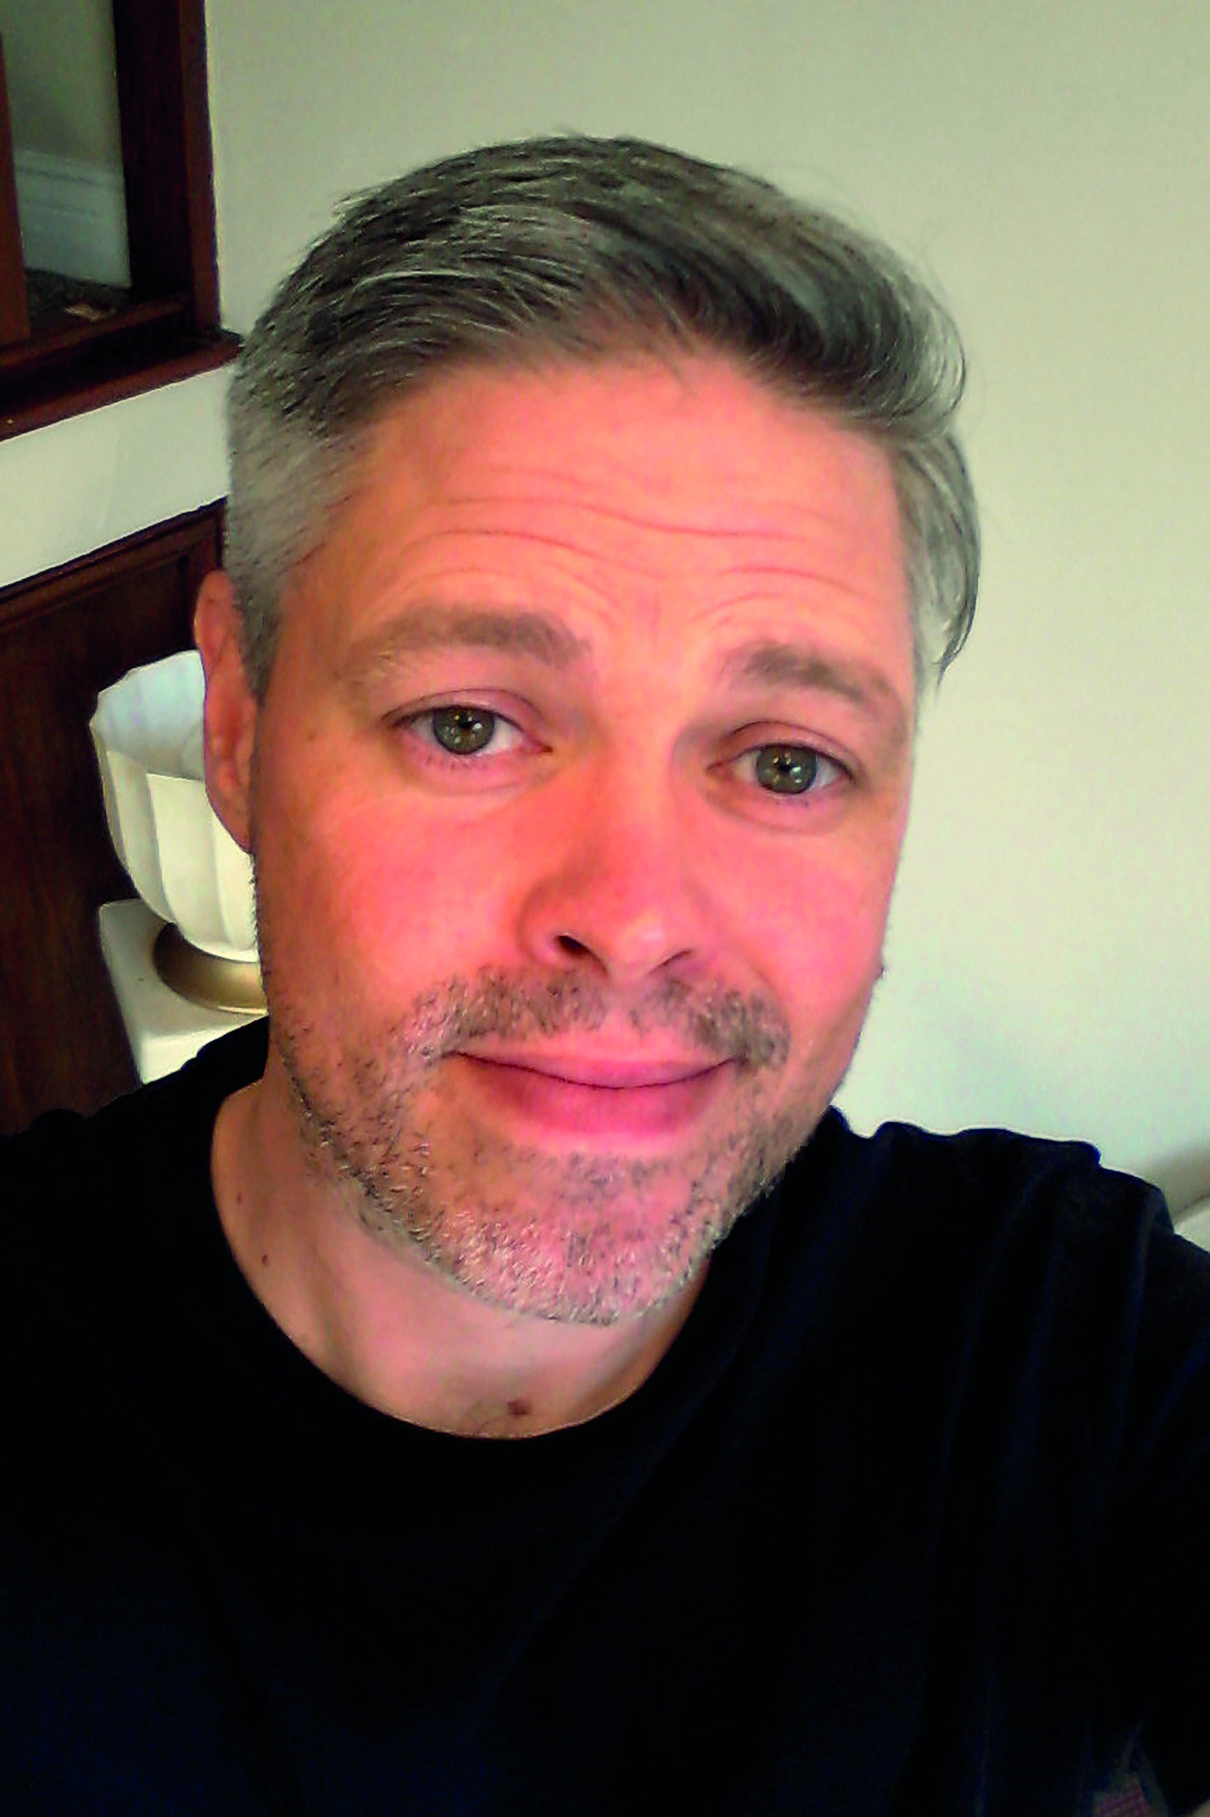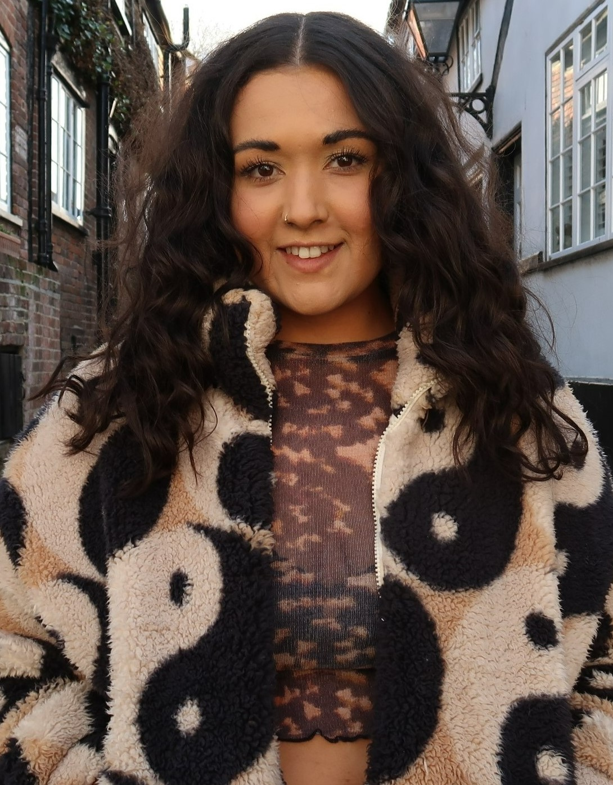
William Hussey and Amara Sage
Get to Know the Authors and the Books!
Parental Pressure
Both of the books feature difficult parental relationships.
Broken Hearts and Zombie Parts:
Morgan: “The problem is, I can’t dig seventeen years of comments and criticisms out of my head just to make you all feel better. If I could, I’d do it for myself too.”
“You mean your mum?” I say.
“Yes, but not only her. It’s everything. Society, culture, social media. A constant noise telling us we’re not good enough.” (P312)
Influential
Almond “I want her to notice the tears threatening to spill, to ask me what’s wrong, to be here for me, present right now, but she looks away, doesn’t see. She’s bent over the camera, puffing out her cheeks and doing the whole self-deprecation routine a lot of us feel compelled to act out whenever we’re confronted with a picture of ourselves. " (P67)
- Think about the different teenage characters in the novels.
Morgan-Jesse-Brianna-Cas-Almond.
- What beliefs, opinions or do their parents or other care-givers have which they project onto the teens. What effects do these have on the young people in the novels?
- Do you think the adults intend for this to happen? What might they do differently if they realised the effects their comments were having on young people?

Mental Health and Body Image
Mental health and body image are important themes in both novels.
Broken Hearts and Zombie Parts:
Jesse
“I hit return and a dozen angelic twentysomethings from my favourite queer online magazine fill my screen. All toned and chiselled and absolutely perfect in every way. One has a tiny mole between the ladder of his abs but is otherwise blemish-free. I slip my hand under my shirt and press it hard against my breastbone... one day that pain will be a memory. The scar will not... I imagine it again – that blazing trail that will soon rip its way down my torso, transforming me, making me the exact opposite of these shining, beautiful people. And I know it’s silly. I know – I know – but I can’t help crying all the same.” Broken Hearts and Zombie Hearts p 47-48
“I just can’t imagine summoning the courage to look at myself in the mirror... if I can’t bring myself to like what I see, how can I expect anyone else to either?” Broken Hearts and Zombie Hearts p102

Morgan
“I don’t understand how someone as kickass as Morgs can be so bothered by how she appears onscreen. Not her acting, which she knows is awesome but – I hate to even think about it – her looks. So here’s the deal – Morgan is convinced she’s ugly and fat and “bulges in all the wrong places” (her words)…. It’s so stupid because I know my friend is beautiful, inside and out. I suppose her fitness-obsessed mum doesn’t help.” Broken Hearts and Zombie Hearts p44

Influential: Almond
In Influential Almond also struggles with her mental health which manifests as self-harm. Her mum insensitively refers to this as “a case of the boohoos.” (p19)
"Scratches rake across my shins like red rivers, open sores dot up my legs like craters dug down into the earth of me, like the terrible aftermath of a natural disaster I inflicted upon myself. Wildfires and sinkholes.” (P226)
- Although the characters mental health struggles are ongoing they all find strategies to help them cope. Which strategies help the characters. Think about:
Relationships and friendships – Exercise – Relaxation – Routines – Switching off.
- Do you have any coping strategies which help when you’re feeling anxious or unhappy. What are they? Can you think of anything else which might be helpful? Share your ideas with your class or a partner, if you feel comfortable to do so.
Influential: Heather
“Look, the road to recovery is not a straight lie... It’s not the A1, alright? There’s gonna be roundabouts and zebra crossings, and, and-” (P224)

Deep Fake
In Influential Almond falls for Joss because he sees the real her, not just the front which she puts on for social media.
- Take a look at your own social media profiless. Do you think the representation of yourself that you share accurately reflects the real you?
- In a pair look at your partner’s socials. Write down 3 words which describe the person represented on the channel. Do you think these 3 words are accurate for your partner in real life? Do any of them surprise you?

Flawless
Almond’s instagram images are always accompanied by a filter to perfect her looks.
- What do you think is the effect of editing/facetuning and constantly seeing “flawless” models and celebrities is on young people? What could be done about it?
- Social media is also criticised as it gives a platform for negative body image, even leading to increases in mental health conditions such as anorexia (for example through hashtags such as #shredding #thighgap or #thinspo)
- Do you think this is true? In what way does social media help to promote these issues? Could anything be done about this by the social media platforms?
- Try to make up some of your own positive hashtags to promote confidence and healthy body image (For an example #hotgirlsummer #anybodyisabeachbody.) What kind of content do you imagine could be posted under your hashtags?

Your Turn
Creative Writing Exercise:
In Influential Amara Sage often incorporates instant messaging or twitter comments in her text
- Try to write your own piece of creative writing using only instant messaging, or social media.
- Think about:
- Your characters. They could be friends or people who’ve never met each other before. (Think about how people can react or appear differently on social media as opposed to in direct conversation.)
- Plot. Try to incorporate a brief plot in your writing. How quickly does it progress using only instant messaging dialogue?
- Format: How can you format your dialogue to make it obvious to the reader that the conversation is taking place on social media or instant messaging?

Further Questions
Lastly, do you have any final questions you would like to ask William and Amara if you got the chance? Try to think of at least two and make a note of them.
Keep your eye out for more awesome books from William Hussey and Amara Sage, as well as the other authors from the Edinburgh International Book Festival!

