Stand Up with Nikesh Shukla
Explore themes of racism, microaggression and comic writing.
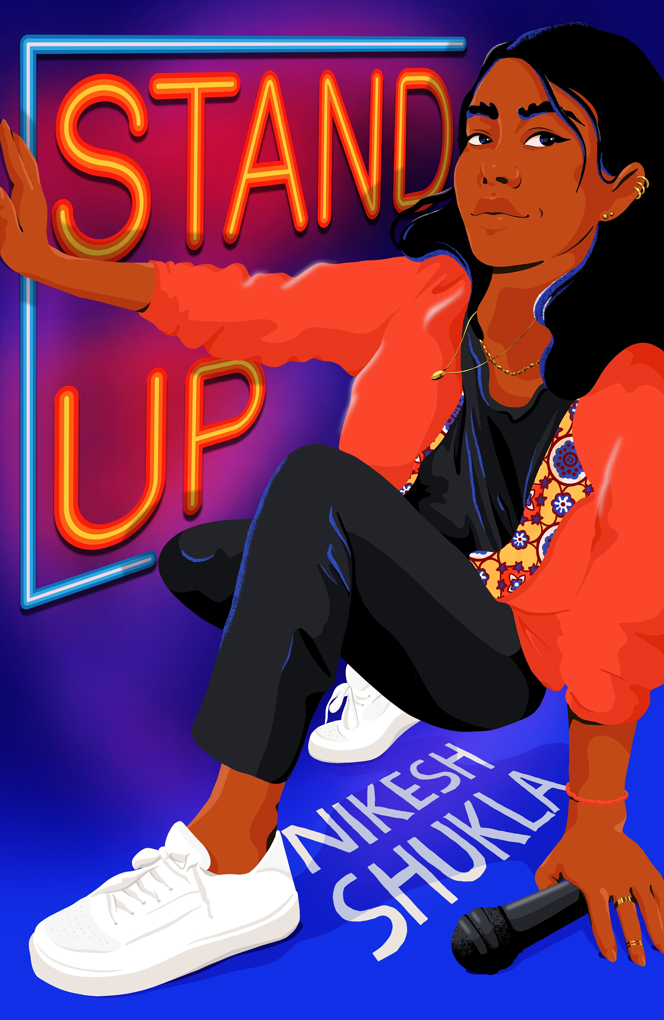
Level:
S1-S3/ Third and Fourth Level
Explore themes of:
√ Racism √ Microaggressions √ Creative Writing
Subject Checklist:
√ Expressive Arts √ English Language √ Social Studies
Note to teachers: These books contain some material that may not be suitable for some students. We recommend that teachers read the books carefully before using it in the classroom or recommending it to students and/or seek parental guidance.

At a Glance
- Look at the book cover. What do you think the book is going to be about? Does the cover make you want to read?
- Who do you think the character in the book cover is? What are their hobbies and how do they spend their time? Are they popular or unpopular?

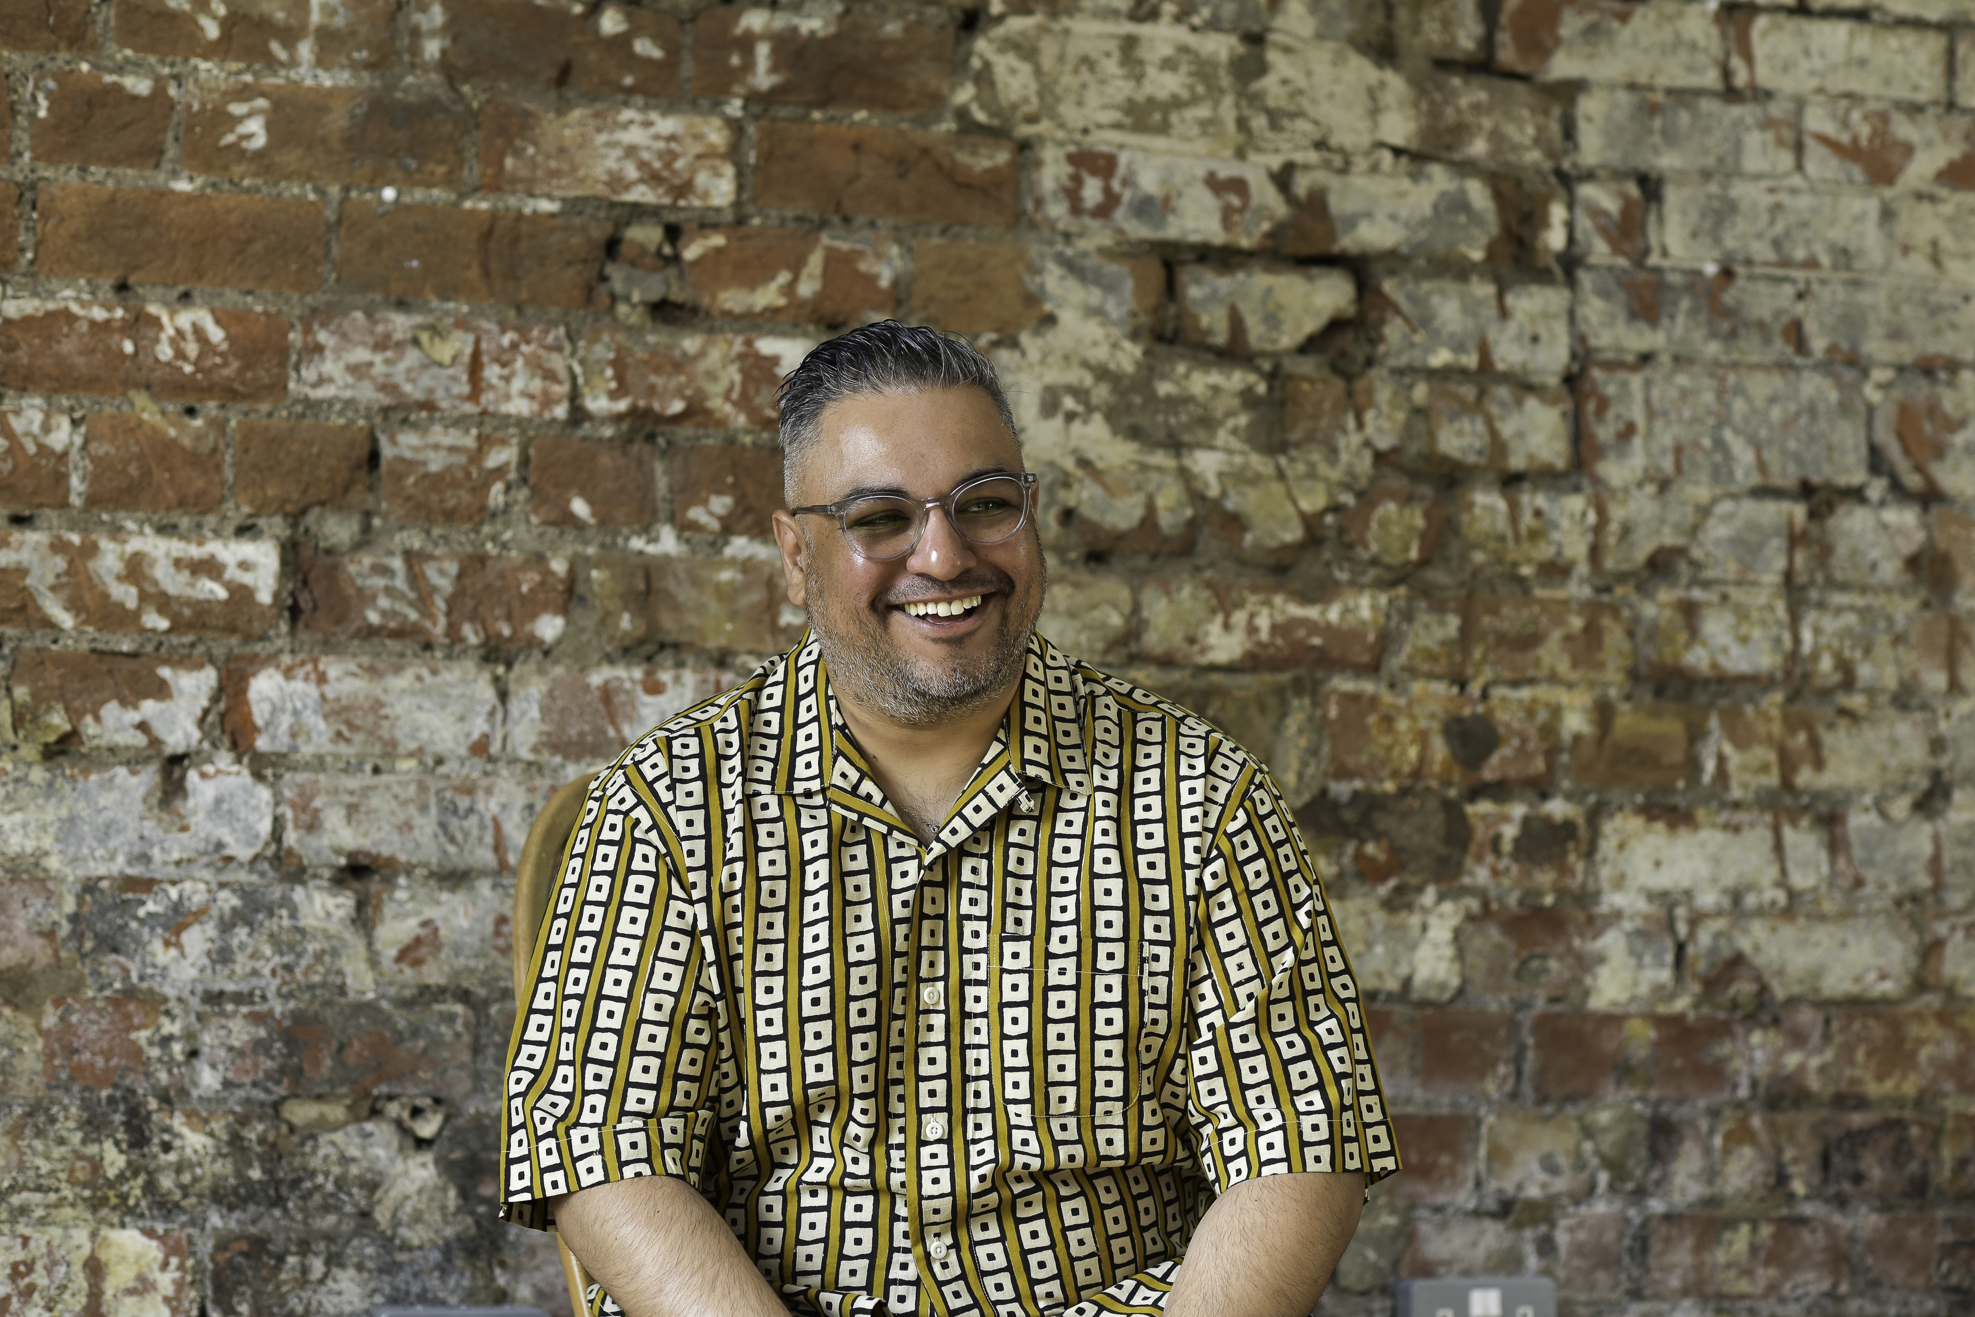
Nikesh Shukla
Get to Know the Author and the Book!
The Good Immigrant
Why not watch this interview, recorded at the Book Festival in 2018, with Nikesh about his book The Good Immigrant where he highlights some important issues about race, society and books.
https://learning.edbookfest.co.uk/resources/lets-talk-about-race-with-nikesh-shukla/

Discussion: Token
[Kareena Patel, Madhu’s comedy idol] “kept referring to the audience of one she had tonight, which was the only other brown girl here because she needed me to leave the club knowing a better world was possible. And the rest of the audience could suck its mum.” (P59-60)
From wearing a sweatshirt which says “token” at her first stand up gig, to being singled out in an audience. Madhu is often aware that she is the only brown-skinned person in the room.
- What effect do you think this has on Madhu? How does it make her feel at different times?
- How do you think it would then feel to find and perform at the Hidden Corner Café, a “space for those of us in the margins just to exist. It’s about solidarity more than it is about critique. We build our confidence here and we just get to be ourselves here.” (P75)
- Have you ever had the experience of feeling like you stand out for a specific reason? How did that make you feel? What effect did it have?

Activity: Microaggressions
“Adibah introduces how the evening’s going to run and the rules: no lazy ‘white people are like so’ jokes, no poems about autumnal leaves, no kicking down or sideways on individual communities or marginalisations. And, Adibah tells us, if someone has feedback on why your work has negatively affected them, you listen non-judgementally. We all have blind spots. All of us. Even using the words ‘blind spot’; I need to ensure it’s not an offensive term. Language is that ingrained in keeping us down. All we can do is hear people and reflect. It’s always what we do next that counts” (P79)

Are you familiar with the term microaggression? What do you understand by it?
The Oxford Dictionary defines microaggression as:
- a statement, action, or incident regarded as an instance of indirect, subtle, or unintentional discrimination against members of a marginalized group such as a racial or ethnic minority.
"the students made signs detailing microaggressions they had heard or experienced"
- indirect, subtle, or unintentional discrimination against members of a marginalized group.
"they are not subject to daily acts of microaggression"

In groups or pairs discuss the following examples from Stand Up:

A receptionist at the TV studio assumes Madhu and Jazz are there for the “diversity day.” P110
Kareenas show being made into a sitcom pilot “in a season of other sitcom pilots by diverse talents that never got made into something longer because ultimately it was a box-ticking exercise and not a shot at the big time.” P113
Madhu being given a “flesh-coloured” headset mic, which isn’t the colour of her flesh. P140
A fellow guest on the show, on meeting Madhu, offers her a fist bump, rather than a handshake. P143
Another guest assumes Madhu is Kareena’s sister, then explains he meant “like sista, with an a.” P145
In Madhu’s imagined future she and her friends, two other “unproblematic people of colour doing law, also from Bristol” get a 2:1 in their degrees “which is great for us because no one even expected us to finish the degree.” P155
A customer at the pizza place asks Madhu to settle an argument between him and his wife about whether the word dungarees is Indian or not. P196

Think about each of the examples above in turn.
- Do you think this is an example of a microaggression?
- If so, what is the “unintentional discrimination” implicit in the situation?
- What do you think the effect of the comment or action is on Madhu? And what might the effect of the build-up of all of these comments/actions over time be?

Your Turn
Creative Writing Exercise:
“... it’d be good for you to think about what you want to use your voice for.
What stories you might want to tell.” P83

Try to think of a funny experience you’ve had or something which you find funny about a situation in you’re in or have been in.

- Think about why you find it funny and try to translate this to the page.
- Try to write the same way in which you would tell the story. It might even be easier to tell your story first, then write it down on the page as you’ve said it.
- Don’t go for the easy laughs. If you’ve learned something from Stand Up we hope it’s that stereotyping isn’t funny!
- Think about your timing. The right pauses can really add humour to your words!
- Why not try out the “rule of three” that Madhu mentions, setting up a pattern of two items, then subverting your rule in the third item, to comic effect.

If you feel comfortable why not try performing your “set” to your class. You could even host your own mini stand-up night with a compere!

Further Questions
Lastly, do you have any final questions you would like to ask Nikesh Shukla if you got the chance? Try to think of at least two and make a note of them.
Keep your eye out for more awesome books from Nikesh Shukla, as well as the other authors from the Edinburgh International Book Festival!

