Confetti by Dean Atta and Alea Marley
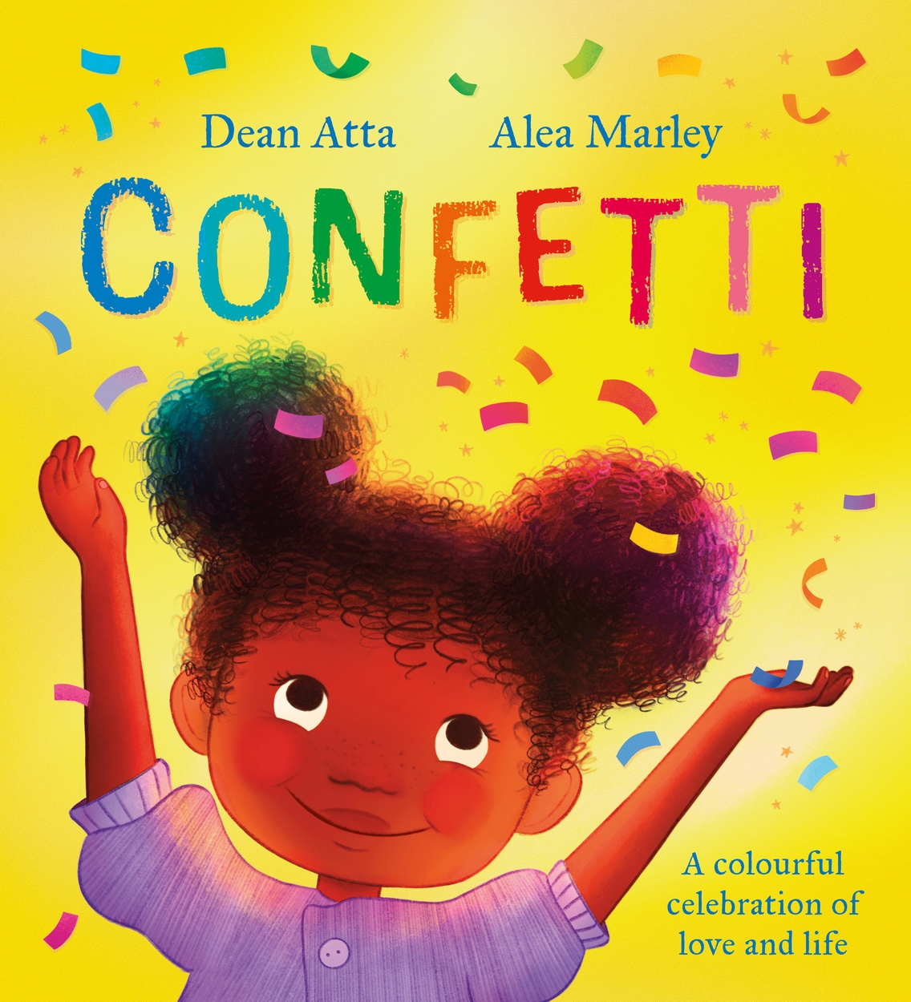
A Sensory Story for those with complex additional support needs (including PMLD.)
We’ve worked with Sensory Storyteller and Founder of My Kind of Book, Ailie Finlay, to create this resource to accompany Dean Atta and Alea Marley’s bright and brilliant book, Confetti.
Confetti is always a popular addition to a sensory story – so how about creating a sensory story that is all about confetti! The picture book Confetti is a lovely warm family story that is perfectly suited for adding in some sensory fun.

You may find the story a little long for children with additional needs if you are adding in confetti and props as well. Try creating a shorter version by including the first section with the pink confetti and then choosing two or three additional sections from those listed below. If you feel the text is a little long you could read the first sentence or two from each double page spread and omit the rest.

You will find that the confetti can have a very calming effect – take your time with the story as the confetti falls slowly to the ground. A little goes a long way!

Confetti and prop suggestions for the story
(Not all of these prop suggestions are toys – they should only be used under adult supervision)

Arianna discovers a piece…
Use one piece of pink confetti and then gradually add more and more as you get to the birthday illustration.

Uncle takes Ari to a parade…
Use rainbow confetti. You might want to use pride flags and banners as well.
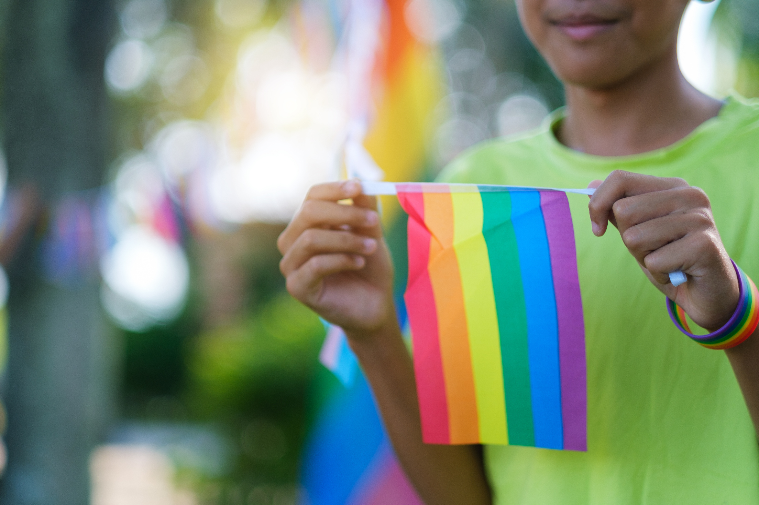

Ari’s family is getting bigger…
Use yellow confetti. You could add in some ribbons as well.

Uncle takes Ari and Andi…
Use orange and brown confetti. Or cut leaves from tissue paper. (Or gather real autumn leaves if it is the right time of year.)

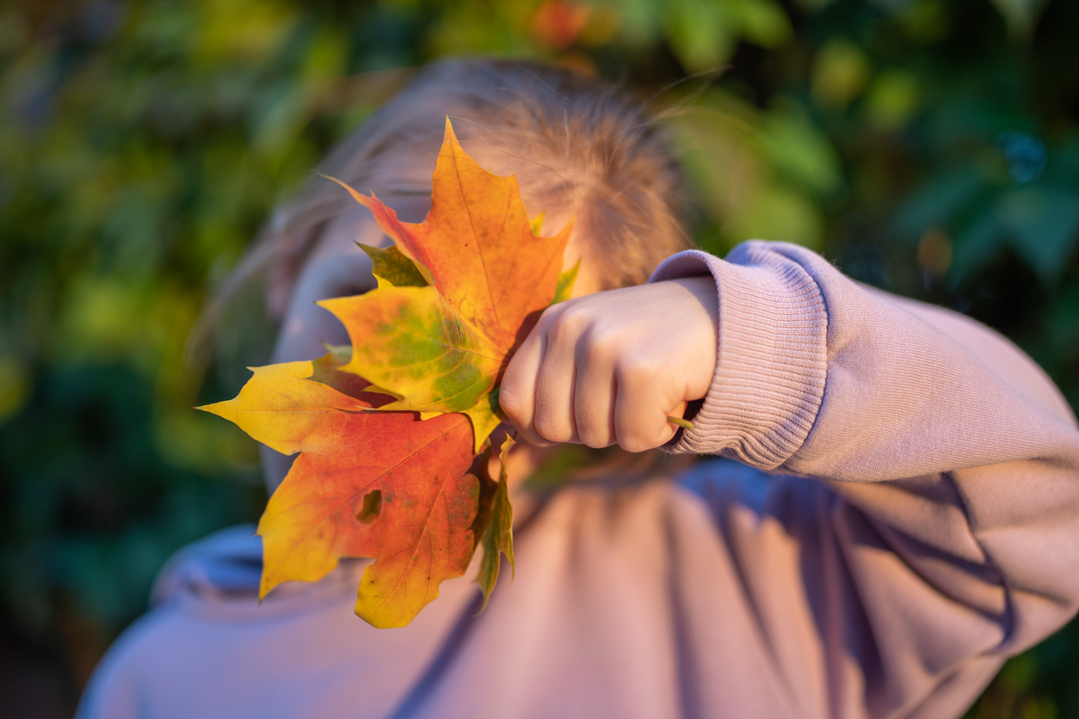

Uncle is getting married…
More rainbow confetti. Try adding some romantic music!
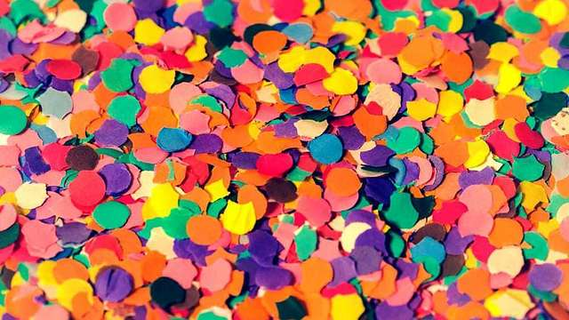

Snow is like cold confetti…
Use white confetti. You could also use ‘a big white blanket’ or some fake snow and ice packs.

When it hits him…
Yet more rainbow confetti! This time count to three and then throw a large handful up in the air all in one go with a big cheer.



