**Thank You by Jarvis**

A child sitting on a moon, with a red hat and boots. There are stars around the moon.
A Sensory Story for those with complex additional support needs (including PMLD.)

**We’ve worked with Sensory Storyteller and Founder of** [My Kind of Book](https://mykindofbook.org.uk/about/)**, Ailie Finlay, to create this resource to accompany Jarvis’ thoughtful and heartfelt book, *Thank You*.**

This book makes a lovely sensory story with its simple text and theme of gratitude. One thing that makes it particularly suitable for turning into a sensory story for children with additional needs is that it is easy to pick and choose pages to include and pages to miss out. (The pages you miss out could either be omitted completely or you could read them but not have any accompanying props.) Choose some pages that you know your child will enjoy and create a story that is just the right length for both of you.

Take time to explore the props with your child as you tell the story. You could try repeating the text from each page several times as you do this.

**Prop suggestions**

**(Not all of these prop suggestions are toys – they should only be used under adult supervision.)**

***The moon****:* Cut a large crescent moon out of thick card. You could cover this with foil if you like. Add a short stick or handle to make it easy to move. Move this ‘moon puppet’ slowly in front of your child as if it is traveling through the sky.

***The sun****:* Make a sun puppet in the same way as you made the moon one. Alternatively put a hand warmer into a little drawstring bag and tie tight shut – this represents the heat of the sun.

***My Boots****:* Put a pair of wellie boots (or other boots) on your hands and ‘stomp’ (clap) them together. Or stomp them on a table or wheelchair tray.

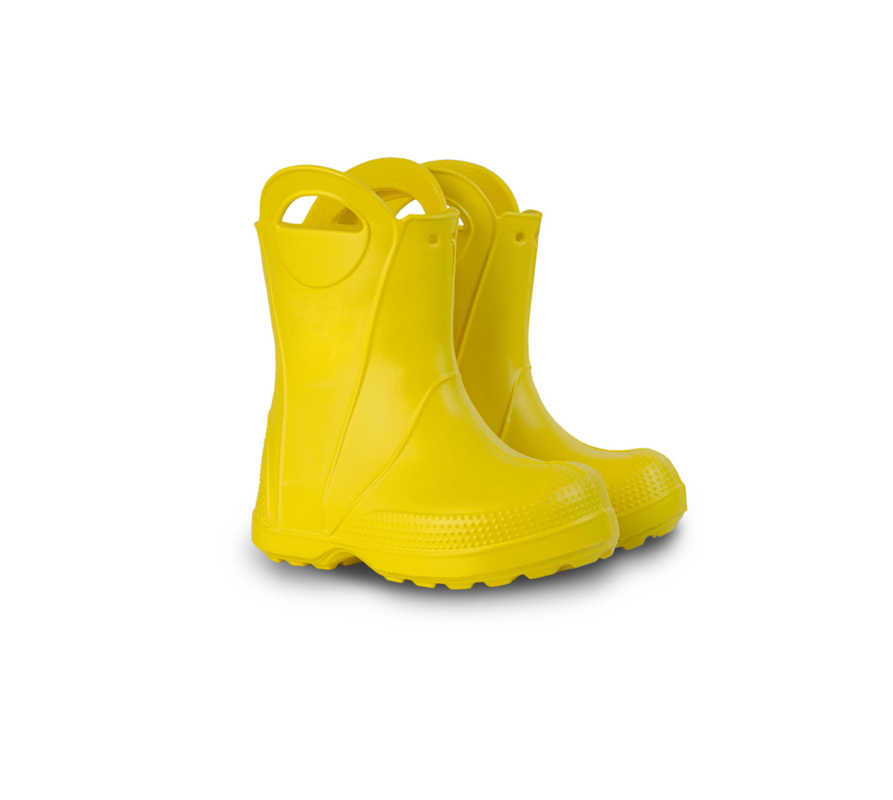

***The shade****:* Use some translucent cloth (maybe a large silky scarf) to make shade. Drape it over you and your child (if your child would enjoy this).

***My Hat****:* Use a hat – or lots of hats! Try throwing them up into the air…

***The clouds****:* Use a gentle spray of water on the back of your child’s hands (if they would enjoy this). Or use a shaker or rain stick.

***The geese****:* Download some cackling geese noises – or make geese noises yourself! Using your thumb and fingers make a ‘beak’ and very gently nibble your child’s fingers.

***Letting us GO****:* Make a green ‘go’ sign to hold up dramatically as you say ‘go’. Or you could use yellow, blue and green scarves.

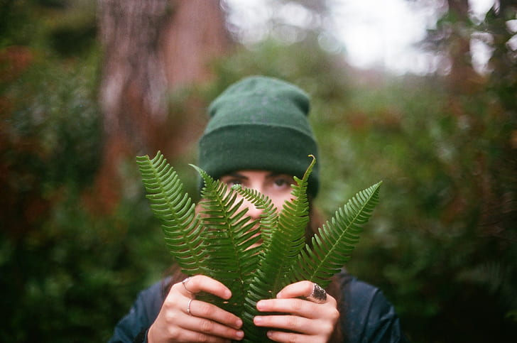***This plant****:* Use a plant (a plastic one would be quite practical for this). Hold it up in front of your face as you say the words – and then peep out.

***The bath****:* A collection of bath toys would be fun to use here. Or you could blow some bubbles.

***Elephants****:* Improvise an elephant’s trunk from an old sock or half of a pair of tights – or just use your arm and playfully (gently) grab at your child with your ‘trunk’.

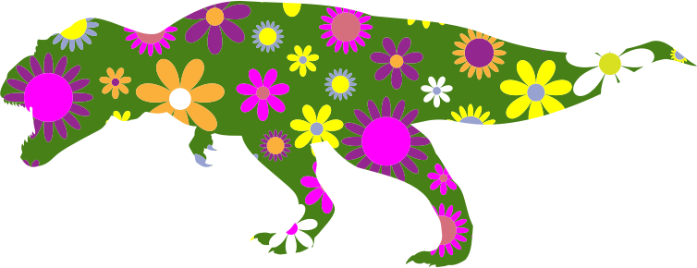***Tyrannosaurus****:* Download some dinosaur noises – or make your own!

***Bowl, spoon, belly****:* Tap a bowl with a spoon – and gently tap your child’s belly.

***Itch****:* Very gently scratch your child’s pretend itch…

***Purrs****:* Download some cat purr noises – or just make your own!

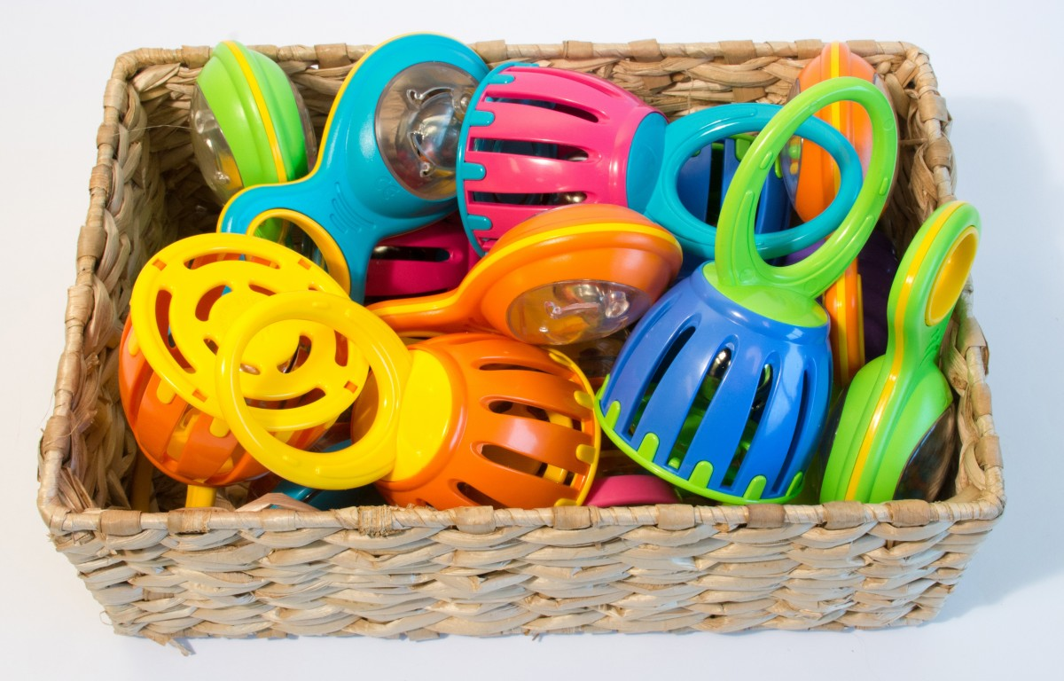***Bicycle****:* Use a bicycle bell- or lots of bells!

***For going first****:* Count to three and mime a big splash with your child.

***Myself for being me****:* Hold up a mirror to your child as you say this. Or use some pots and pans and wooden spoons as drums!

***Everything all over again****:* Let your child choose which ‘thank yous’ they would like to say again.

**Telling the story in a classroom?**

If you are telling the story to a class or group, consider having multiple copies of some props so that the children are not having to wait too long while the objects are handed round.

You could download noises and sound effects on to switch voice recorders to enable the children to join in (rain, geese, elephant, dinosaur, cat purring). Encourage any other adults in the room to join in with all the noises so that the children are surrounded by the sounds.

Maybe your class would like to create their own version of this story? Each child can choose one thing they would like to say ‘thank you’ for. (These could be choices from the book, or from their own lives.) Then find a prop to represent each child’s choice.

**Follow-on fun**

This book provides lots of opportunities for play…maybe there are certain spreads or props/actions that your child particularly enjoys? Pause every now and then and see if any little games develop between the two of you. Here are some ideas (but you and your child may come up with ideas that are much more interesting than these!)

***My Boots****:* Gather together different shoes and boots. Make different types of steps and stomps according to the kinds of shoes you have on your hands: Heavy stomps for big boots, little steps for high heels, baby steps for baby shoes etc. Or you could tear old newspapers into ‘stepping stones’ – a bit like the stone illustrations on this page. Put these on the floor and have fun stomping from stone to stone. Remove ‘stones’ one-by-one to gradually make the ‘stomps’ longer and longer!

***The shade****:* Using the ‘shade’ cloth play peek-a-boo: Cover yourself with the cloth and say: ‘*Who’s that hiding in the tree? 1,2,3…’* Pull off the clothand say: ‘*It’s me!’* Take it in turns to do this. Or take the book outside on a sunny day and share this page (and others) under a shady tree.

***My Hat****:* Play catch with the hat.

***The clouds****:* Dress up in all your rain clothes and take it in turns to spray each other with the water spray. Or spray yourself!

***Letting us GO****:* Using your ‘go’ sign play ‘stop and go’ with your child – take it in turns to use the sign to order the other to ‘stop’ or ‘go’.  Alternatively mix some yellow and blue paint to make green. Or you could turn empty boxes into train carriages – like the ones in the illustration.

***This plant****:* More opportunities for peek-a-boo!

***The bath****:* Linger over some bubble blowing – who can pop the most?

***Elephants****:* Give elephant rides on your back – if your child is small enough and your back is strong enough!

***Bowl, spoon, belly****:* With a toy tea set or plastic cups and bowls play ‘the dinosaur came to tea’! (Take it in turns to be the badly behaved dinosaur.)

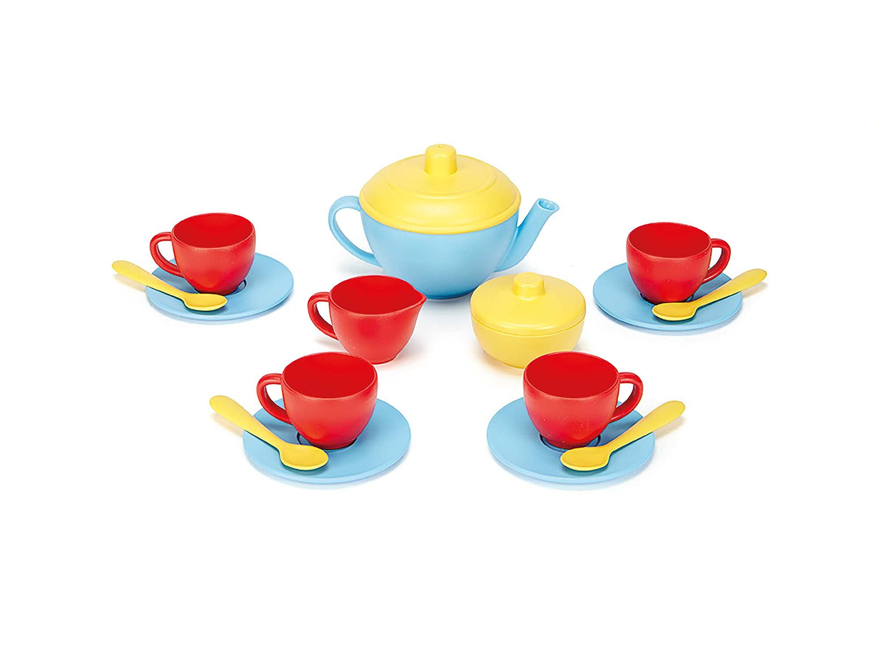

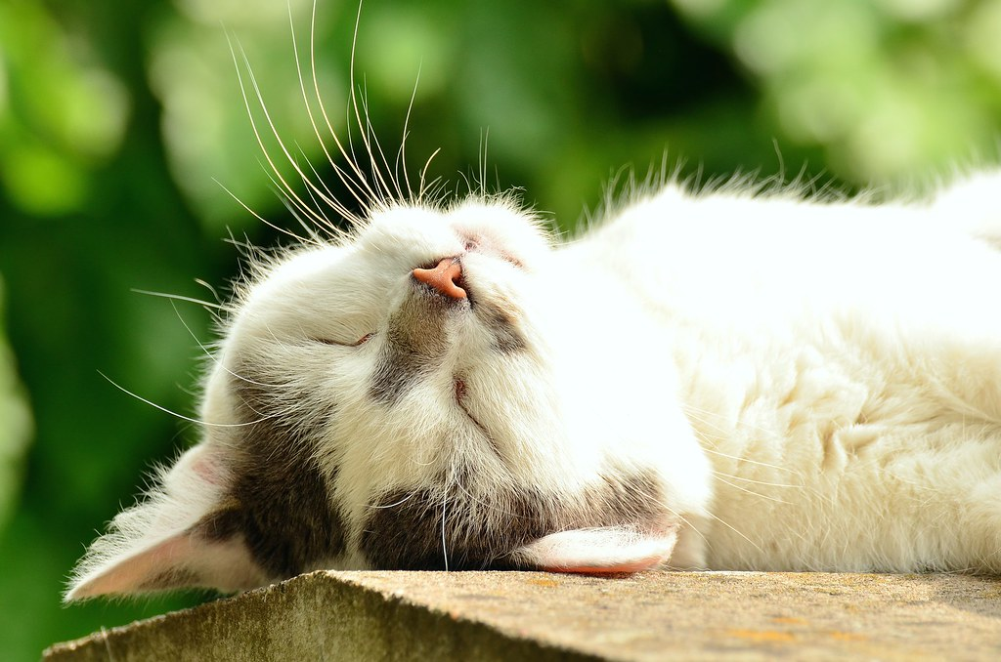***Purrs****:* Play at sleeping cats – one person ‘sleeps’ (eyes shut) and purrs – the other person wakes them up.

***For going first****:* Make a ‘swimming pool’ of cushions for your child to jump into. Or count to three and then ‘splash’ by covering them with the big translucent cloth…

*Add in your own ‘thank yous’ at the end.* Take it in turns to choose things you would like to say thank you for. Gather props for these as well if you like.

**For children who enjoy very sensory fun:**

Try just sharing one spread from the book with your child and then dive straight into a fun sensory activity:

***The clouds****:* Dress up in all your rain clothes, find some puddles and jump in them!

***Letting us GO****:* Make yellow, blue and green slime or playdough. (There are lot of recipes for slime and playdough online.) Use sticks, forks etc and encourage your child to make swirls and lines in the dough or slime like those in the illustration of the smoke.

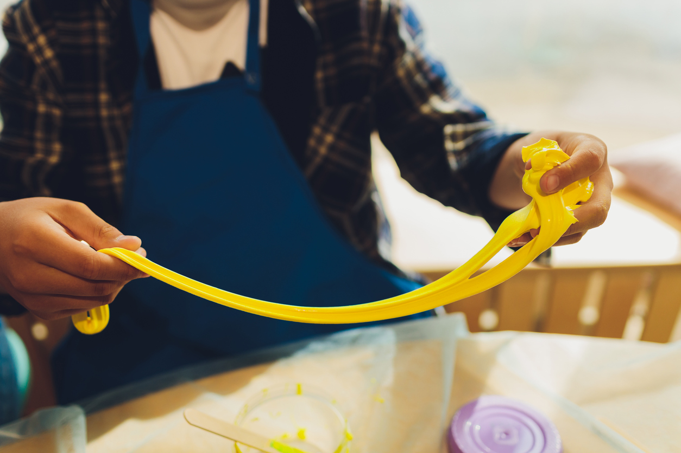

***The bath****:* Fill a washing up bowl with warm water, bubbles and bath toys.

*Bowl, spoon, belly:* Make a bowl of jelly and splat it, squish it and jiggle it. (This will get a bit messy!)

A spoon in a bowl of red jelly


***Bicycle****:* Use potato prints to make bicycle wheels and then draw in the bikes and scooters. Or just do the wheels! (Look online for potato print instructions.)