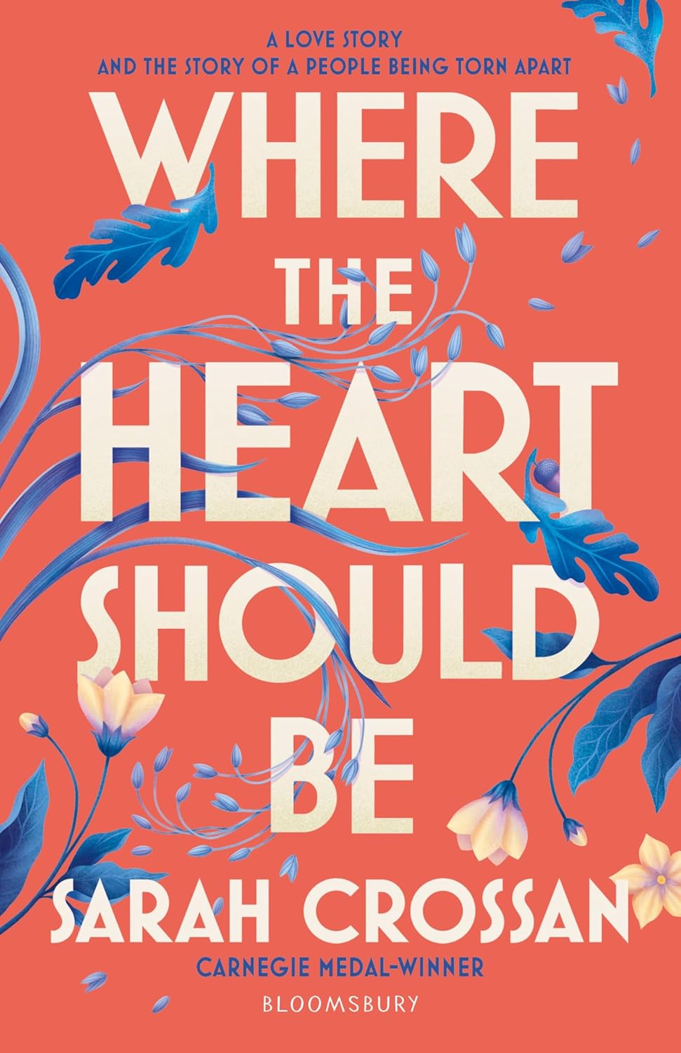

**Where the Heart Should Be Learning Activities**

**Learning activities to support a class reading of *Where the Heart Should Be* by Sarah Crossan**

**Level:**S3-S6/Third and Fourth Levels and Senior Phase

**Explore themes of:**  
Ö Love and Family Ö The Great Hunger Ö Poetry Ö Historic Fiction  
  
**Subject Checklist:**  
Ö Expressive Arts Ö English Language Ö Social Studies

**Activity One: Discussion – England and Ireland Relations**

* Re-read pages 135 – 138. There is a high tension and distrust presented between the Irish and English. Despite this, Nell continually battles between what is ‘right’ and what is ‘wrong’.
* Quote:

*But Daddy would raise hell*

*if he knew about Johnny.*

*I’m sure of it.*

*My whole life I have been*

*taught not to trust the British.*

*‘Bastards took our land,*

*our language,*

*would get rid of the lot of us too*

*if they could,’ Daddy once said.*

* Spend 15 minutes researching The Great Hunger. See if you can find any interesting facts or evidence of bad relations between England and Ireland to back up why Nell’s dad doesn’t trust the British. Feed this back to the class.
* Put yourself in Nell’s shoes. Can you make two lists; one with reasons why you **should** be with Johnny, the other for the reasons you **should not** be with Johnny
* Sarah Crossan places a poem about what Nell likes about Johnny next to a poem about Nell’s internal conflict about the situation. Why? How does that make you feel?

**Activity Two: Structure**

Re-read pages 171 – 172. The structure of a poem can significantly impact its meaning and effect. In this section, Sarah Crossan has chosen an unconventional structure.

* What is the impact of this structure and the flow on the page? How does it make you feel?
* Can you see a link between the poem and its title?
* Can you find another page or poem which has an interesting structure in the book? What is the impact of this, and why would Sarah Crossan write your selected page in this way?

**Your Turn: Step back in time**

What is ‘historical fiction’? What do you think might be challenges for writers of historical fiction?

* This book is set during The Great Hunger in Ireland in the mid 1840s. Imagine you stumbled upon a time machine, and you could go back, as Nell, to the end of the book in 1847. What has happened? What has changed? How do you feel?
* Write a brief report, addressed to the government in Westminster at the time, to let them know what is happening in Ireland.
* Once the report has been written, swap with a partner to read theirs and discuss the similarities and differences of your ideas and writing.

**Further Resources**

* **Authors Live;**
  + **Sarah Crossan’s event at the Edinburgh International Book Festival was filmed by BBC Scotland in partnership with Scottish Book Trust as part of their Authors Live series. You can watch this back on** [iPlayer](https://www.bbc.co.uk/iplayer/episode/m0022lpd/authors-live-authors-live-sarah-crossan) **of via their** [website](https://www.scottishbooktrust.com/authors-live-on-demand/sarah-crossan)**.**
* **Edinburgh International Book Festival – for more learning activities on historical fiction novels;**
  + [Protecting your furry family through thick and thin: While the Storm Rages by Phil Earle – Learning | Edinburgh International Book Festival (edbookfest.co.uk)](https://learning.edbookfest.co.uk/resources/protecting-your-furry-family-through-thick-and-thin-while-the-storm-rages-by-phil-earle/)
  + [Whose Side Are You On? Historical Fiction with Liz Kessler and Alex Wheatle – Learning | Edinburgh International Book Festival (edbookfest.co.uk)](https://learning.edbookfest.co.uk/resources/whose-side-are-you-on-historical-fiction-with-liz-kessler-alex-wheatle/)
  + [Which Witch? – Learning | Edinburgh International Book Festival (edbookfest.co.uk)](https://learning.edbookfest.co.uk/resources/which-witch/)
* **Sarah Crossan;**
  + **Interview with Sarah Crossan on *Where the Heart Should be* on the Reading Zone** [website](https://www.readingzone.com/authors/sarah-crossan/)**.**
  + **Video:** [Sarah Crossan on why the verse novel appeals to her as a writer.](https://www.youtube.com/watch?v=rmLQATvDcP0)
* Information on The Great Hunger;
  + [Ted-Ed Talk by Stephanie Honchell Smith about wht really caused the Irish Potato Famine.](https://www.youtube.com/watch?v=OUieqzVZdQc)
  + [BBC History: British History in Depth: The Irish Famine.](https://www.bbc.co.uk/history/british/victorians/famine_01.shtml)
  + [Famine Collection Page: The Great Irish Famine.](https://www.scoilnet.ie/go-to-primary/theme-pages/history/famine/)

**Suggested reading**

If you enjoyed this book and want to try some other similar titles, we’ve included a selection of recommendations that you can share as a class or pass on to learners.

In The Key of Code by Aimee Lucido

The Poet X by Elizabeth Acevedo

Let Me Tell You This by Nadine Aisha Jassat

Run Rebel by Manjeet Mann

The Crossover by Kwame Alexander

We Come Apart by Brian Conaghan and Sarah Crossan

The Black Flamingo by Dean Atta

The Rest of Us Just Live Here by Patrick Ness