**Spooky Poems Aloud**

Activity ideas to explore poetry, rhythm and rhyme to primary school-age children

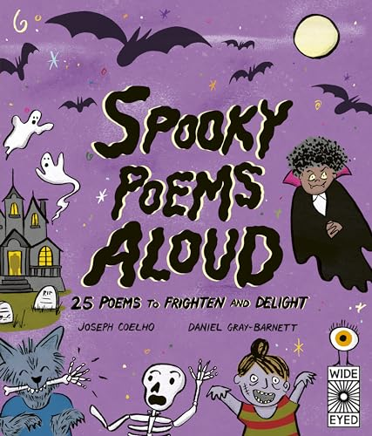

**Level**P2-4, First Level

**Explore themes of**

Halloween

Storytelling

Poetry

Performance  
  
**Subject Checklist**

Social Studies

Literacy and English

Expressive Arts

**About this resource**

The aim of this resource is to give ideas on how to introduce poetry through cross-curricular learning activities for children in P2-4. It contains ideas for exploring poetry and writing in your classroom as well as inspiration for using the book across the curriculum as part of Halloween themed activities.

If your school attended the Spooky Poems Aloud event at the Edinburgh International Book Festival, each child will have received a copy of the book. The event is also available to watch on-demand on the Book Festival’s website.

**Introducing the book**

Look at the cover of the book as a class and ask the students to guess what characters and themes might be featured. Can they guess what other characters might appear based on the ones on the cover? *Spooky Poems Aloud* is great for tying in with other Halloween activities and could act as inspiration for a performance at a Halloween Party in school.

**Literacy and English**

**Sound poems**

Using the poem, *Clomp!* (pp.34-35) as a prompt and starting point, discuss different sounds that we hear day-to-day and ask the children to share examples.

What is the impact of the different types of words used to describe a sound? Did it slow down the poem or speed it up at any point? Was it louder or quieter?

Try using different sound words to create your own poems. You could use the prompt about a disembodied body part to get started!

**Class rules**

The book features poems about *Club Rules* (pp.14-17) where there is a list of rules to follow if you want to join particular monster clubs. Can you come up with Club Rules for your class? What would be allowed? You could use your Class Charter as a starting point and create a poem inspired by it.

**Feel the poem**

Creating atmosphere is a great technique when writing poetry as it can take just a few words to convey a feeling! Pick some objects around the classroom or playground as a starting point for a poem, then imagine these objects in a spooky place. What describing words would you use to create a spooky atmosphere?

**Noisy poems**

Onomatopoeia is another technique poets use to bring their writing to life. Write a poem using words that make a sound e.g. you could use Autumn and the changing seasons as inspiration, with “crunching” leaves and “whooshing” wind.

**Expressive Arts**

**Learn from the best**

Poetry can take many forms, one of which being performance-based. [Watch Joseph Coelho’s event at the Book Festival](https://www.edbookfest.co.uk/media-gallery/item/poems-aloud-with-joseph-coelho) as a class and discuss his performance. How does he use his voice? Do you think the actions add to the event?

**Poetry styles**

There are lots of ways to perform a poem. Explore different poetry events and see if you can spot the similarities and differences. Watch [The A-Z of Poetry with Michael Rosen, Carol Ann Duffy, Tom Pow & John Sampson](https://www.edbookfest.co.uk/media-gallery/item/rosen-michael-the-a-z-of-poetry) at the Book Festival which features a selection of poets and their different performance styles.

**Find the right rhythm**

Having watched or listened to a poet perform their work, use the event as a starting point for discussion about rhythm. What did your pupils notice about the rhythm and pacing of the poem? Did it slow down or speed up at any point? Explain that all poems have a rhythm or pace which is created by the words the poet has chosen, their use of punctuation and their use of rhyme. You can practice this by clapping your hands, stamping your feet or nodding your head along to a poem.

**Social Studies**

**Compare cultures**

Countries all around the world celebrate Halloween and do it in different ways e.g. trick or treating in America and guising in Scotland. As a class, compare Halloween celebrations and create a display featuring the countries and their activities.

**Spooky origins**

Halloween is an annual celebration which dates to as far as the 8th century and was originally a Celtic festival. Visit the library and find out about the history of the holiday and how it’s changed over the years.

**Further book suggestions**

*Poems Aloud* by Joseph Coelho

*Michael Rosen’s Book of Very Silly Poems* by Michael Rosen

*A Whale of a Time: A Funny Poem for Everyday of the Year* by Lou Peacock and Matt Hunt

*Poems to Perform* by Julia Donaldson

*I Am the Seed That Grew the Tree* by Frann Preston-Gannon

*Daydreams and Jellybeans* by Alex Wharton

*Zooming the Zoo* by John Dougherty and Tom Morgan-Jones