Women are Legends too: Reimagining Fantasy with Laura Bates, author of Sisters of the Sword and Shadow and Sisters of Fire and Fury

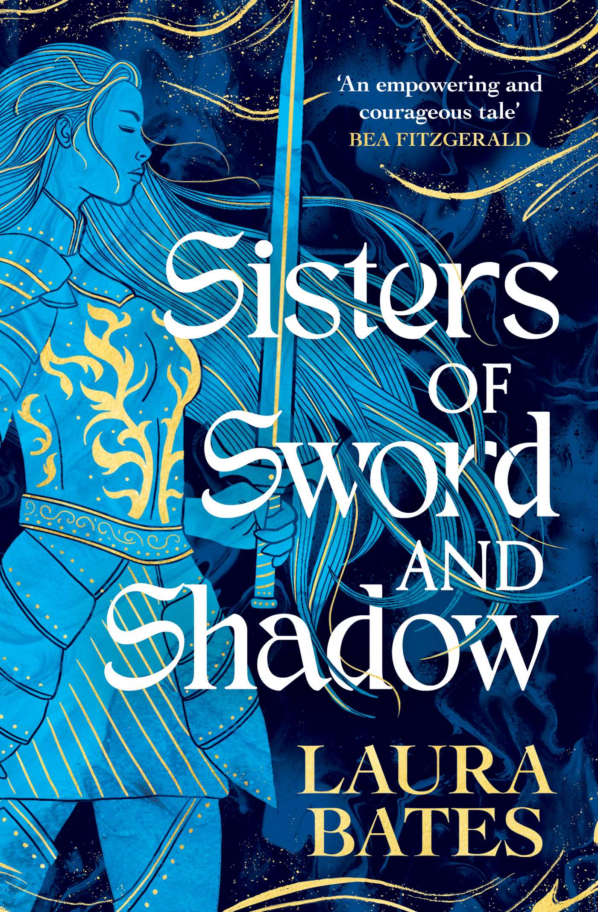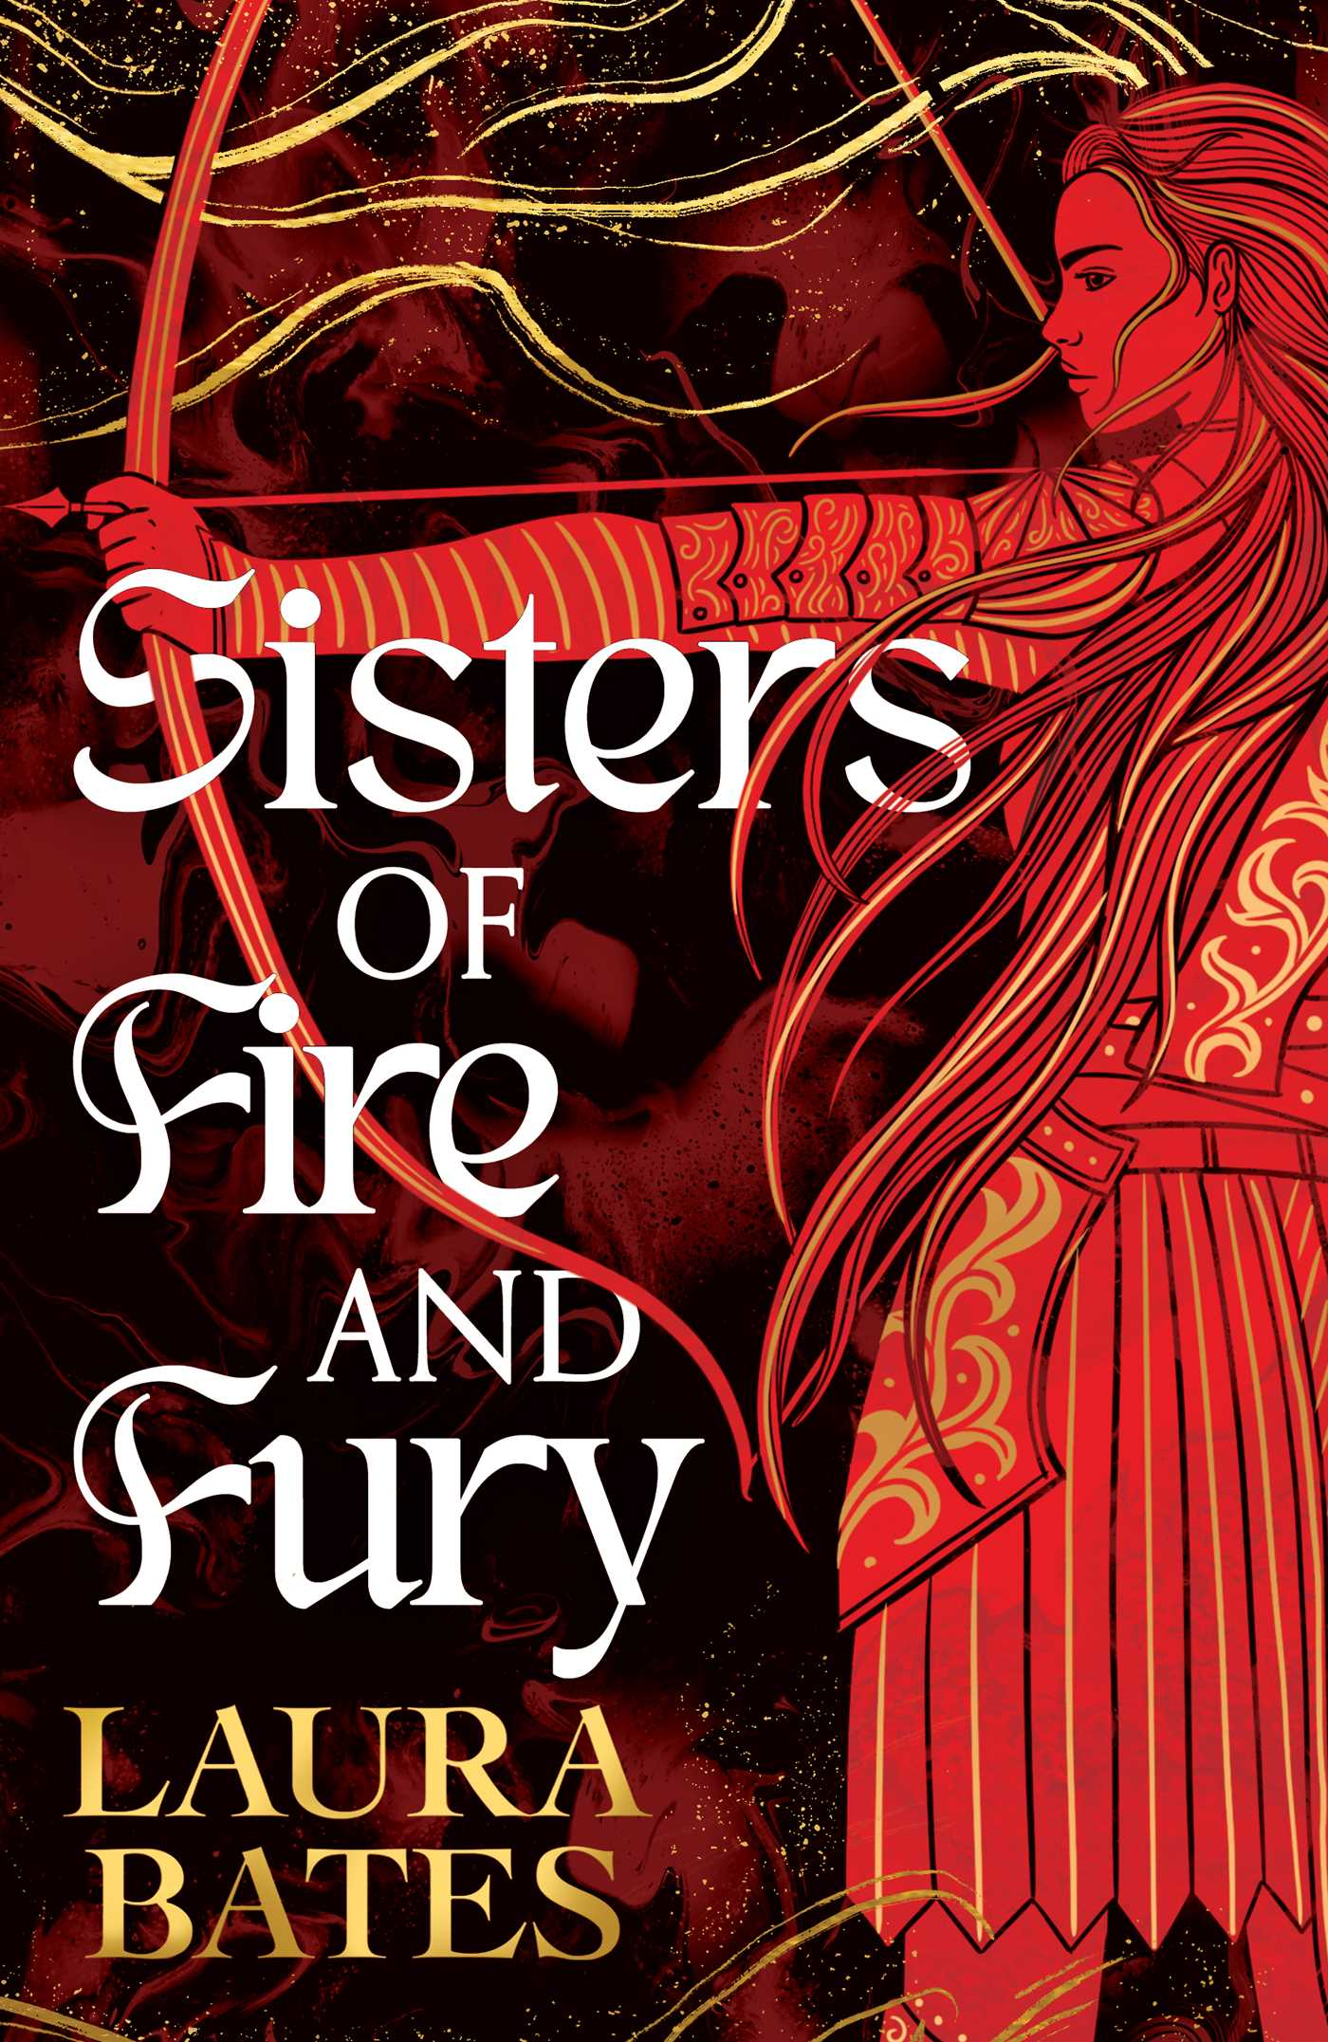

Explore this breathtaking fantasy duology by activist, writer, speaker, journalist and founder of the Everyday Sexism project, Laura Bates.

Level:
S4-6 / Senior Phase
Explore themes of:
Power, Love and Fury, Sisterhood, Grief, Chosen Family, Feminism
Subject Checklist:
Expressive Arts, English Language, Social Studies

Note to teachers: We recommend that teachers read the books carefully before using it in the classroom or recommending it to students and/or seek parental guidance.

This learning resource focuses on the first book in the duology, Sisters of the Sword and Shadow, but includes some questions related to Sisters of Fire and Fury at the end.

Activity one – Get to know the author
This activity can be delivered pre-reading the book.
This duology is Laura Bates’ fantasy debut. Bates is one of the UK’s leading and bestselling feminist writers. Before reading, create a fact file on Laura Bates by researching her previous work – what are her other books about? What are the themes within her work? What does she care about?
Now, consider (in groups) what you think this duology will be about, or the themes it could tackle based on your research on Bates, the titles and book covers. Here are some discussion points to get started:
- Think of the words within the titles – swords, fury, fire versus sisters. What are the stereotypes of these words? What does it make you think of?
- Knowing Bates’ past books, what could she be trying to do here with the title and book covers?
- Before you read the books, write down three assumptions you have on these books based on your research. Remember to check back once you’ve read them to see if you were right!

Activity two – A feminist retelling
This activity can be delivered while reading the book.
What is literary (or critical) lens?
Literary lenses are like glasses that allow you to see things from a particular perspective. When you’re wearing these glasses, you interpret what you read in a certain way, in line with that perspective. By examining writing through a critical lens (Feminist, Post-Colonial, Marxist, etc) we can uncover new layers of meaning and an array of interpretations.
From your initial pre-reading research, you’ll know more about Laura Bates, her activism and her feminist writing. As you’re reading, consider Bates’ writing through a feminist lens, and what bigger meanings and issues Bates is connecting to in her writing.
Below we’ve included some specific quotes, near the start of the book, to discuss and analyse.
Chapter 5
- P.36 – Cass describes what she believes a knight is, ‘A knight shows valour…A knight is brave and courageous and puts the needs of others before his own…A knight saves damsels- or at least he is sworn to fight to protect women, and to uphold the values of chivalry and courtesy.’

Later down that same page, Angharad explains what knight is in the Sisters of Sword and Shadow, ‘We are a group of women who, for many reasons, have not found lives for ourselves that we can accept outside these walls. So we gather here. And we make our own rules. We defy anybody who believes that only men can fight; that valour is inherently a masculine virtue. We believe there is a life for us with a higher meaning than marriage and servitude, which so often come interlinked. We believe we have as much right to knighthood as men do, and we do not timidly seek permission to call ourselves knights. We simply prove it.’

- P.41 – Cass asks Sigrid about the consequences of letting a man (who she fought) live, knowing that she is a woman. “’An interesting thing happens, when a man is defeated in combat by a woman.’ Angharad nodded. ‘He tells nobody’.”
Discussion points:
- How are knights typically represented? Who are the famous knights in historic tales?
- In many ways, this book is seen as a feminist retelling of the Knights of the Round Table. What does it mean to place women’s stories within this classic and well-known legend?
- Why do you think Laura Bates has chosen to base her book on a story about knights who have to conceal their gender?
- Are there any similarities between ‘sisterhood’ and ‘knighthood’? Any differences?

Task:
- As you go through the book, can you collect quotes that further substantiate the discussion points above?

Activity three - Love, grief and fury
This activity can be delivered towards the end of reading the book or after reading the book.
The main themes in both novels include love, grief and fury. These emotions play out within the text both when characters are in battle and when they are living day-to-day in society. One particularly interesting thing Bates does is explore how people are able to channel their emotions and how love, grief and fury can be interconnected and, at times, symptoms of each other.
Once you have read the full book, or have got past this passage, take a look at the quotes below, found in Chapter 35 and 36, page 346-350. You could share these quotes out amongst your class, for tables to discuss in groups and then feedback to the class:
- ‘A woman keening, distraught, her voice more animal than human.’
- ‘Rowan’s cry of fury as she spurred her horse forwards, the whistling of her blade as it swished through the air and then sang out as it met the sword of one of the men…’
- ‘Without thinking, without fear, Cass drew her sword too, and charged into the fray alongside Rowan, a bright burning fury filling her with a heat so great it seemed to radiate out of her.’
- ‘Everything poured out of her, through her hands and into her blade. Her grief for Vivian, the injustice of Mordaunt’s abuse of his people, the fear that she was about to lose her home and her purpose. Her power took over her, completely. Ruthlessly.’
- Following the death of one of her friends – ‘Cass did not stop. She did not cry or bend down to touch the body or let herself feel the impact of the grief like a great hammer to her belly. She took up her sword and mounted Pebble and rode back to the manor as if a thousand wolves were chasing her.’
- ‘She could not contemplate grief or let it in because it would swallow her whole.’
- Sigrid says to Cass – “‘I know what it is to be consumed with grief’…’Your anger is like a flame. You must feed it enough to keep it alive. But if you allow it to burn too bright it will reduce you to ash before you are able to act on it.’”

Discussion points:
- Bates often presents love, grief and fury as all-consuming. Is this present in your selected quote? How does she do this? What is the effect?
- Go back to your feminist lens – is there anything further you can read into your quote? Maybe consider how women’s emotions (or an ‘emotional woman’) are typically perceived?
- The passage suggests lots of hardships within society at the time. What other emotions may be present within the passage other than love, grief and fury or who else will be feeling these emotions in the text?

Tasks:
- In this passage one emotion sparks another, can you create a timeline of the different states of emotion (and what causes the emotion) within this passage (p. 346-350).
- Bates uses similes and metaphors to portray the high level of emotion and urgency within this passage, such as ‘[she] rode back to the manor as if a thousand wolves were chasing her’, ‘your anger is like a flame’, etc. Now create your own simile or metaphor for each of the emotions – love, grief and fury.

Creative Writing Exercise: Reimagine one of the final scenes
This activity can be delivered after reading the book.
On one of the final pages of the book, the Sisters of the Sword reveal their unexpected identity to Mordaunt’s knights. Read the passage below (p. 381).
‘Very slowly, keeping the sword’s sharp point at the base of Mordaunt’s’ throat, Angharad reached up and pulled off her helmet, allowing her long red hair to fall like a curtain around her shoulders. ‘We have lived in fear long enough’, she said quietly, and as Mordaunt gaped and paled so fast that Cass thought he might faint or vomit, every other female knight and squire in the courtyard pulled off their own helmets too.
For what felt like a very long moment, they all stood there, in the bright morning light, their heads held high. Knights, openly, proudly, for the first time. And the shock and confusion of the men around them was sweet.’

Now we’d like you to reimagine this scene and rewrite your own version. You can either:
- Write an alternative ending to this scene. Is there a different reaction from the rest of the women when Angharad reveals her identity – do the rest of them pretend they’re men and are also shocked by this revelation? Do one of Mordaunt’s knights recognise their own mother/sister/daughter as one of the Sisters of the Sword? Is there a different reaction from the men?

- Or rewrite this passage within a different context. Is there another environment where someone can be unmasked and reveal themselves as something else? What other roles and positions are typically reserved for men? Or could the unexpected identity reveal something other than an unexpected gender?

Questions related to Sisters of Fire and Fury
If you’re already reading (or have read!) Sisters of Fire and Fury (the second book in the duology), many of the activities above also relate to this text. Here are some further discussion points to think about:

- There are many moments of love and battle within the text, particularly between Cass and Gamelin. Can you pick out any quotes that evidence this and explore these further? (Hint: you can find some on pg. 55-56 and pg.95-98).
- Why may Bates have chosen to depict love as well as battle? Does it change how you perceive Cass (or other powerful women who are in love, such as Angharad)?
- There is a strong sense of destiny, knowing who you are, answering your calling and a coming-of-age element of the plot. Have a look at pg. 193-195. Cass battles with her powers throughout the book and takes time to come to terms with who she is. Do you have favourite scenes which depict this mental battle? How does the sword help to visualise this within the story?
- Power is a main theme within the book and there are many power battles portrayed. One notable one is with King Arthur, Merlin and the other knights of the roundtable. Can you pick out any interesting quotes which highlight power struggles within the text? (Hint: you can find some on pg. 339, 340, 382).

Watch Laura Bates at Edinburgh International Book Festival 2025

We were lucky enough to have Laura Bates speak at the Book Festival this year to over 400 pupils at McEwan Hall as part of our Schools Programme. Watch it back and recreate the Book Festival in your classroom!

Women are Legends too: Reimagining Fantasy with Laura Bates

We’ve all heard the legends of King Arthur, Excalibur and the Round Table. But what if it wasn’t him who really united the kingdom of Britain? What if it was a powerful knight who also happened to be a woman? Laura Bates gives the inside scoop on Sisters of Fire and Fury, the sequel to her bestselling Sisters of Sword and Shadow, conjuring a world of old magic, battles, and a mythic showdown - and explores how we can move through fear to find our courage.

Women are Legends too: Reimagining Fantasy with Laura Bates | Media | Edinburgh International Book Festival

