My Granny Went to Scotland by Mike Nicholson
A Sensory Story for those with complex additional support needs (including PMLD.)
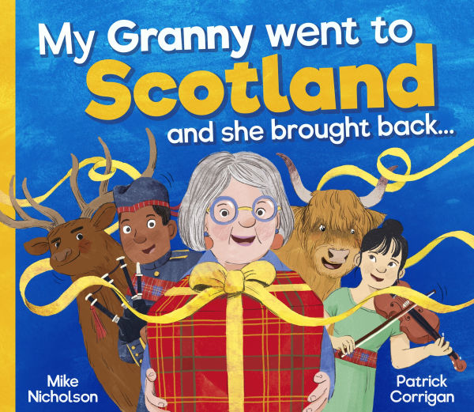

We’ve worked with Sensory Storyteller and Founder of My Kind of Book, Ailie Finlay, to create this resource to accompany Mike Nicholson’s humorous book, My Granny Went to Scotland.
This lively picture book by Mike Nicholson and Patrick Corrigan is perfect to turn into a sensory story. It includes lots of lovely repetition and each double page spread is easy to link to one sensory prop. It lends itself to quite a rambunctious telling so be prepared to throw yourself into it and ‘gie it laldy’!

It is not a problem if you do not have an object to use for every page – just add in some miming or actions. I think that with this sensory story the objects do not necessarily have to be an exact match for those mentioned in the book…you could ad lib a little bit to include objects that you have to hand. (E.g. If you do not have any tartan fabric or scarves just use what you do have and add it into the text. So, if you have a stripey scarf you would say: ‘ticklish tartan…and ticklish stripes…’) The main thing is just to have fun with your child – with silly objects, silly noises, silly faces and silly actions!

When you are running through the list of things that granny brought back it might be best to do this without actually using all the props each time. Using every prop that is mentioned as you go through the list may be a bit too much – just use your own judgement. It would definitely be good to use all the props for the last noisy run through just before the Loch Ness monster makes an appearance though.

If you are telling the story in a classroom, you could put each child in charge of one prop at this point. When that prop is mentioned the child joins in. If the children enjoy this then try adding in some repetition and running through the list a couple more times.

Prop suggestions
Remember these prop suggestions are not toys and should only be used under adult supervision.

Having multiples of some of the props can be a good idea if you are sharing the story with a class.

Sugary shortbread: Use a biscuit tin or empty shortbread box. Put something like a couple of pieces of Duplo inside and then tape it tightly shut. Rattle the tin or box!

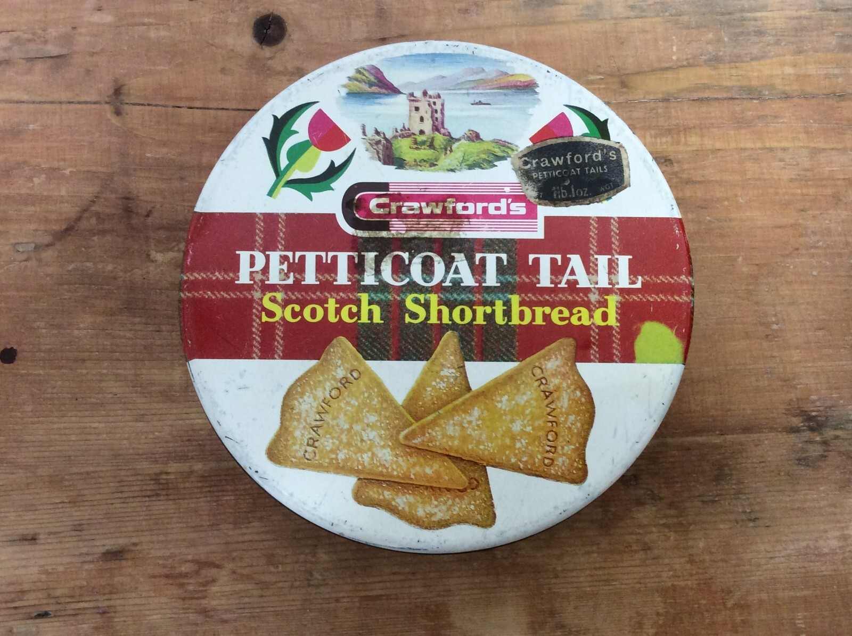

Ticklish tartan: one or two tartan scarves or other tartan fabric would work well. Waft these around!

A daft wee dog: Use a toy or puppet dog if you have one – make it jump around and bark. Alternatively, you could make the dog’s wee white tail by rolling up some white paper or tissue paper, taping it together and then snipping it at the end to make a sort of tassel. ‘Wag’ this wee tail over your child’s hand to tickle them while you make barking noises. You want to create a feeling of chaos and energy for the dog…

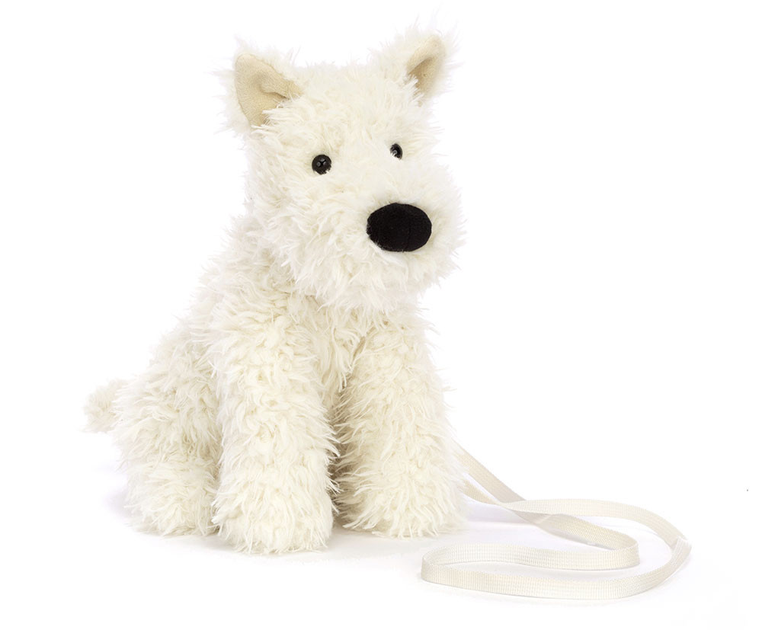

A bellowing bagpiper: Mime playing the bagpipes or play a little bit of bagpipe music. Do some dancing!

A hairy Highland cow: use a moo sound effect (or just moo yourself) whilst giving yourself ‘horns’ with your fingers and stomping all around. Encourage your child to stomp with you. If you happen to have a brown blanket or cover you could put this over your shoulders while you are role-playing the cow. Or if your child prefers tactile props you could use a rope mop-head for the hairy cow.



A cumbersome caber: A swimming noodle makes a good caber. Or anything light, long and round. If you cannot find anything suitable just improvise by rolling up a newspaper and taping it together. Carry it upright in one hand using your other hand to hold it up and sway it all around. Pretend it is large and difficult to balance - even if it is actually not very big at all!

A stamping stag: Use two plastic pots or two lids from laundry liquid or something similar. These should make a good ‘clip, clop’ sort of sound when you bang them together. Let your child help. (Or if you are telling the story to your class you could give out lots of lids so everyone can join in).

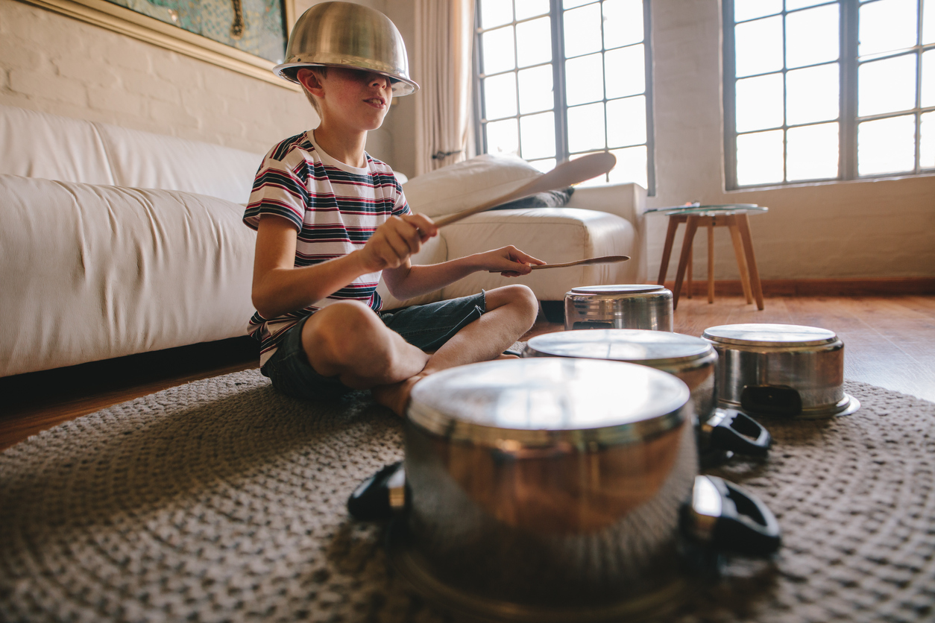

A captivating ceilidh band: Put on some Scottish ceilidh music and dance along. Join in with any instruments you have to hand – or use pots and pans for drums. Remember to shout out some ‘hee-ughs’ in the traditional way!

The legendary Loch Ness monster: You (or your child) could role-play the Loch Ness Monster! Or have fun making a long lumpy monster by stuffing the leg of an old pair of tights (with more old tights or something similar) and sticking on some paper eyes. Pretend that this is the scariest monster ever and use it to ‘get’ your child (if they enjoy this kind of play). If you are telling the story in a classroom and have a budget for props you could try a dinosaur swimming ring. These can easily be found online and make quite good Nessies!

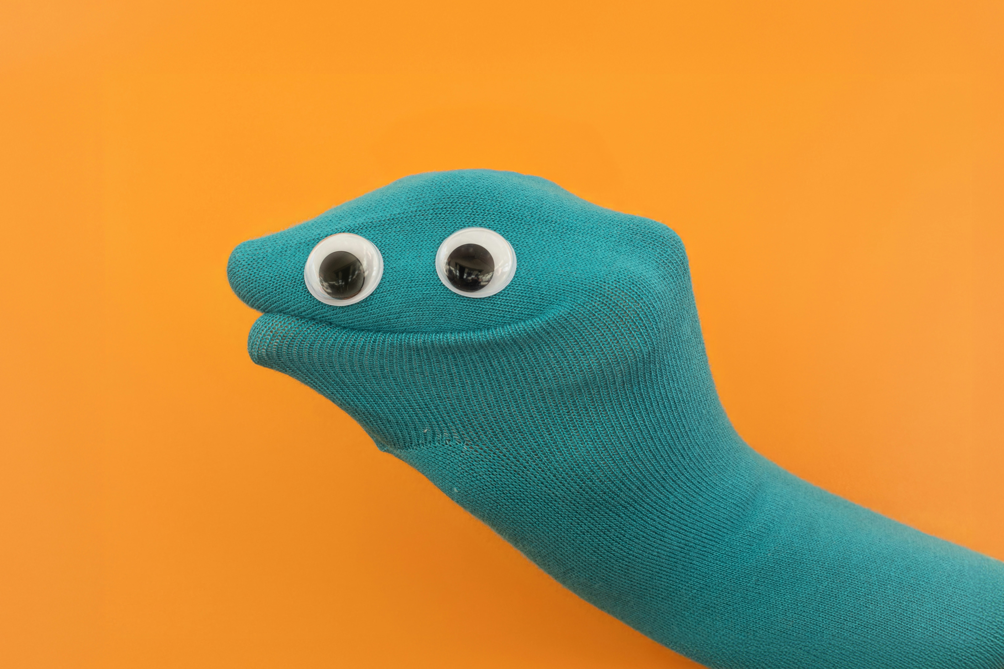

My granny went back to Scotland and she bought back: Try adding your own objects into the story. Maybe granny brings back:

A sea haar (mist): Use a large silk scarf or piece of fabric, preferably something semi-transparent. Drape this over your child’s head (if they enjoy this).

A neep (turnip – or swede in England): cut a whole turnip in half and let your child feel and smell it.

The scent of broom: Use a little bit of vanilla essence on some cotton wool. (Yes, broom flowers do actually smell of vanilla!)

A haggis: Try making a haggis out of the leg of an old pair of tights – stuff it and then tie a knot in each end. Have fun throwing it around!

A flock of sheep: Use some sheep’s wool and sound effects (or ‘baa’ yourself!)

A jar of heather honey: offer your child a taste or let them smell the honey. (If you are telling the story to a group of children you are not familiar with check with parents before offering a taste.)



‘A shower of rain’ might be a nice way to finish off your sensory story. If you finish with granny bringing back some Scottish rain there are a couple of different prop options you could choose from. You could either create lots of excitement by using a spray bottle and spraying your child (or class) with water. Or you could finish with some gently falling confetti for the rain. (Try cutting up tissue paper very small to make confetti.) Choose according to whether you want to ‘go out with a bang’ or finish with something that is calming.

Follow on fun:

Ask your child (or learners and staff team) to make suggestions for things that they would add to the story. If you like you could create a completely new version of the story with these chosen objects.

Use the template of this story to create new versions about other countries. For example: My granny went to France and brought back a long baguette, lavender from Provence, a bottle of perfume, a big round cheese…

Or zoom in on one particular local place that your child knows well and make up a story together. For example: My granny went to North Berwick and brought back a bucket and spade, some sun cream, sea shells and seaweed, a cold ice lolly, a noisy seagull and a pony from the top of Berwick Law. (You could also change the story so that it has your child as the main character, rather than ‘granny’.)

©Ailie Finlay, My Kind of Book (mykindofbook.org.uk)

